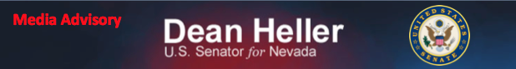
For Immediate Release: Contact: Chandler Smith
November 8, 2013 202-224-6244

Advisory: Heller Celebrates Veterans Day
Media Advisory:
U.S. Senator Dean Heller (R-NV) will attend the following events in honor of Veterans Day:

Saturday, November 9th
What: Senator Heller speaks at event to recognize Nevada’s women veterans
When: Saturday, November 9th at 10:00 a.m. PT
Where: Pahrump Veterans Memorial
751 S. Pahrump Valley Blvd
Pahrump

Monday, November 11th
What: Senator Heller attends Veterans Day Parade
When: Monday, November 11th, 9:30 a.m. PT
Where: Parade runs along 4th Street
Las Vegas

Monday, November 11th
What: Senator Heller attends Veterans Day Ceremony in Boulder City
When: Monday, November 11th, 1:30 p.m. PT
Where: Nevada State Veterans Home
100 Veterans Memorial Parkway
Boulder City

###

