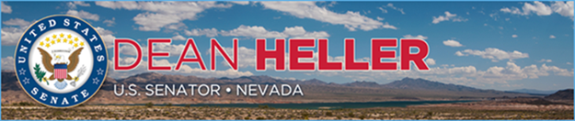

|  |  |
| --- | --- |
| **For Immediate Release:** | **Contact:** [Megan Taylor](mailto:Megan_Taylor@heller.senate.gov) |
| August 22, 2017 | 202-224-6244 |

**Heller Highlights Legislative Success to Protect Lake Tahoe At Summit**

*Heller Led Bipartisan Effort to Restore Lake Tahoe Region*

**Reno, N.V.** – U.S. Senator Dean Heller (R-NV) today spoke at the 21st Annual Lake Tahoe Summit highlighting the Lake Tahoe Restoration Act, legislation that was signed into law in December of 2016. Introduced by Heller along with U.S. Senator Diane Feinstein (D-CA) to restore the Lake Tahoe Area, the Lake Tahoe Restoration Act is the product of years of bipartisan collaboration to ensure Lake Tahoe remains a clean, safe, and vibrant outdoor destination for both Nevadans and tourists alike.

“As a lifelong Nevadan and an avid outdoorsman, I remember my first visit to Tahoe with my father and since then, have passed that same appreciation and respect for the Jewel of the Sierras along to my four children and two grandchildren,” **said Heller**. “This lake isn’t just special to me and my family, but the source of memories for countless families and tourists across the globe. That is why I led the effort in the U.S. Senate alongside Senator Feinstein to preserve Lake Tahoe for generations to come and I was proud to see it signed into law at the end of last year after years of bipartisan collaboration. At today's summit we discussed the important of protecting Lake Tahoe, and while our work is not over - the Lake Tahoe Restoration Act is a significant step toward achieving that shared goal."

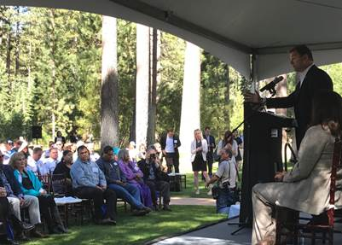

*Senator Heller addresses attendees*

During his remarks, Heller touted the benefits of the Lake Tahoe Restoration Act, which include a substantial $415 million investment over seven years to improve Lake Tahoe’s water clarity, reduce risks from catastrophic wildfires, combat invasive species and restore and protect the environment in the Lake Tahoe Basin. A portion of this multi-million dollar investment goes toward clean, safe transportation projects like new bike trails, the restoration crumbling roads and bridges, and other innovative transportation solutions that reduce congestion and protect the lake. The legislation also works to build a better community by funding community outreach and education, so basin residents and visitors can join in the fight to build a better Lake Tahoe.

Heller joined U.S. Senator Feinstein, the host of this year's summit, along with Governor Brian Sandoval and U.S. Senators Catherine Cortez-Masto (D-NV) and Kamala Harris (D-CA).

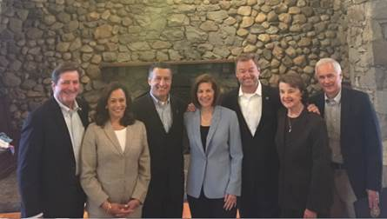

*Left to right: Congressman John Garamendi, Senator Kamala Harris, Governor Brian Sandoval, Senator Catherine Cortez-Masto, Senator Dean Heller, Senator Diane Feinstein, Congressman Tom McClintock*

*###*

[cid:image002.png@01D31B3C.405AB330](http://www.facebook.com/pages/US-Senator-Dean-Heller/325751330177)[cid:image003.png@01D31B3C.405AB330](http://twitter.com/SenDeanHeller)[cid:image004.png@01D31B3C.405AB330](http://www.youtube.com/user/SenDeanHeller)