

|  |  |
| --- | --- |
| **For Immediate Release:** | **Contact:** [Megan Taylor](mailto:Megan_Taylor@heller.senate.gov) |
| May 16, 2017 | 202-224-6244 |

**Heller Honors Detective Chad Parque, Fallen Law Enforcement Officers on Senate Floor**

**Washington, D.C** – In honor of National Police Week, U.S. Senator Dean Heller (R-NV) spoke on the U.S. Senator floor today to pay tribute to fallen Nevada law enforcement officer Detective Chad Parque and pay tribute to the police officers who have lost their lives in the line of duty. Click [HERE](https://youtu.be/2P1SdLJUAB0) or below to watch Heller’s speech.

[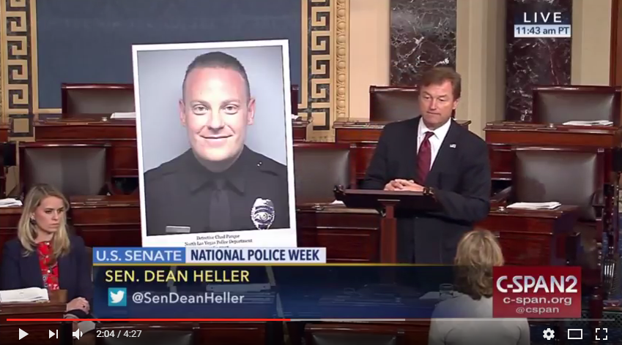](https://youtu.be/2P1SdLJUAB0)

[Click [here](https://youtu.be/2P1SdLJUAB0) or on the above image to watch.]

**Remarks as prepared for delivery:**

“I rise today in honor of National Police Week.

“Since it was established by Congress in 1962, National Police Week is an opportunity to pay tribute to the law enforcement officers who have lost their lives in the line of duty.

“It is also an opportunity to recognize and thank the members of our law enforcement community in Nevada and throughout the country.

“Each day, our law enforcement officers put themselves at risk to protect our families and our communities.

“Their courage, selflessness, and commitment to serve is a reflection of what makes this country so great. And that’s their willingness to answer the call – without being asked – to put the welfare of others over self.

‘This commitment doesn’t come without tremendous sacrifice. And I was reminded of that earlier this month at the 30th Annual James D. Hoff Peace Officer Memorial in Reno.

“The James Hoff Peace Officer Memorial is a tribute to Nevada law enforcement officers killed in the line of duty. The memorial also recognizes officers who were placed in danger and survived.

“Named after Reno police officer James Hoff who was killed in 1979 by the suspects he was investigating, the memorial hosts an annual ceremony attended by state and local officials and members of the law enforcement community.

“It is always a privilege to attend this annual event honoring the heroism of fellow Nevadans whose names and legacies are enshrined in the memorial.

“At this year’s ceremony, we honored and celebrated the life of Detective Chad Parque, who served with the North Las Vegas Police Department for ten years.

“At just 32 years old, Detective Parque tragically lost his life after his department vehicle was struck head-on by another vehicle earlier this year. Detective Parque is survived by his wife, children and siblings and mourned by all of those who had the privilege to know him.

“In describing Detective Parque, a fellow law enforcement officer said: "He was a ten-year officer and you could see the fire in his eyes as if he just signed on. He loved his community.”

“He served with passion and dignity and we will never forget his many contributions to North Las Vegas and to our state.

“His plaque is now alongside other members of Nevada’s law enforcement who were enshrined on this memorial from past years and whose stories continue to inspire us all.

“In 2016, more than 140 law enforcement officers across the nation lost their lives in the line of duty – an increase from the previous year.

“Let us not forget that behind the many names of those who have fallen…are the people – spouses, children, parents – who may not have had the chance to say goodbye. Most of us will never know their pain, but we are deeply appreciative of their unwavering support for the community.

“And while there is nothing we can do to bring back those who have died in the line of duty, I’m committed to doing everything I can at the federal level to try to prevent it from happening to one more officer and one more family.

“I am proud to support the Back the Blue Act, legislation that increases penalties for killing law enforcement officials.

“The bill ensures anyone who purposely targets law enforcement would face justice for that crime.

“Nevada’s law enforcement community has my full support…this Police Week – and every week and day that they are on the job.

“To all law enforcement officers: we are all indebted to you and your families for all of your sacrifices, and I am personally and sincerely grateful for your dedication to the people of Nevada.

“To our protectors and our peacekeepers. To those who are the first to answer the call for help and run toward – not away – from danger – we thank you. And we honor you.”

*###*

[cid:image002.png@01D2CD66.FDD0BF00](http://www.facebook.com/pages/US-Senator-Dean-Heller/325751330177)[cid:image003.png@01D2CD66.FDD0BF00](http://twitter.com/SenDeanHeller)[cid:image004.png@01D2CD66.FDD0BF00](http://www.youtube.com/user/SenDeanHeller)