

|  |  |
| --- | --- |
| **For Immediate Release:** | **Contact:**[Megan Taylor](mailto:Megan_Taylor@heller.senate.gov) |
| September 14, 2018 | 202-224-6244 |

**Heller Hosts Roundtable Discussion with Veterans in Reno**

**RENO** – U.S. Senator Dean Heller (R-NV), a senior member of the U.S. Senate Veterans’ Affairs Committee, today hosted a roundtable discussion in Reno, Nevada with veteran organizations, members of his Veterans Advisory Council and representatives from organizations that include the Nevada Department of Veterans Services, Nevada VA Regional Office, VA Sierra Nevada Health Care System, VA Salt Lake City Health Care System, and Northern Nevada Veterans Resource Center.

Since 2012, Heller has held roundtable discussions with veterans and his Veterans Advisory Councils in both northern and southern Nevada to discuss critical issues impacting the veteran community. Heller then develops policy solutions to address those challenges, and as a result he has authored, helped introduce, and navigate into law more than 40 pieces of legislation designed specifically to help Nevada’s 300,000 veterans, 19 of which have been signed into law by President Trump. Most recently, Heller’s measures to [increase options for veterans in need of an organ transplant, enable VA physicians to spend more time with their patients, and enhance transparency at the VA](https://www.heller.senate.gov/public/index.cfm/pressreleases?ID=CFEFA8BC-5617-41EA-8B18-DA3A2254F863) were [enacted as part of the John S. McCain III, Daniel K. Akaka, and Samuel R. Johnson VA Maintaining Internal Systems and Strengthening Integrated Networks (VA MISSION) Act](https://www.heller.senate.gov/public/index.cfm/pressreleases?ID=16A57032-7A99-42A8-8BF1-0A4FE56B8C97), bipartisan legislation that directs more than $50 billion to improve the VA’s health care system, expand eligibility for caregivers, and make it easier for the agency to recruit and retain doctors.

“Nevada is home to around 300,000 veterans, and I am proud to have the opportunity to serve as their voice in Washington, D.C,” **said Heller**. “The feedback that I received from today’s discussion will help me develop policy solutions to address the challenges facing northern Nevada’s veteran community. From introducing a bill to ease the doctor shortage to working to make sure that our military heroes with invisible injuries can get the mental health care services they need and deserve, I have consistently acted on the valuable input I get from discussions just like the one we had today. Another good example of that is my work to help deliver $33.5 million in federal funding for construction of the Northern Nevada Veterans Home located in Sparks so that veterans in the north don’t have to drive 500 miles to Boulder City to access the State Veterans Home.**”**

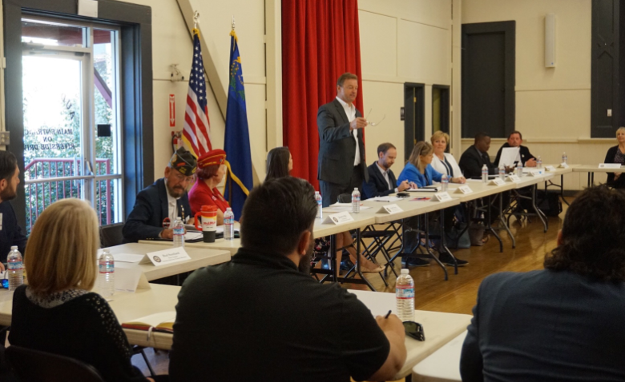

*Heller welcomes veterans to roundtable, reinforces the impact that roundtables have on legislation*

*Media has permission to use photograph*

During the roundtable discussion, many veterans voiced their concerns about the lack of disability benefits for Blue Water Navy veterans who had been exposed to Agent Orange during the Vietnam War, and VA Secretary Wilkie’s opposition to legislation (S.422) that would extend disability benefits to these veterans. Heller, who is a cosponsor of this legislation, [shared the same concerns and reacted to Secretary Wilkie’s opposition to the bill by urging him to reconsider supporting it](https://www.heller.senate.gov/public/index.cfm/pressreleases?ID=5F20177E-4A17-4057-BB4E-13AE6370CFA7). During a [U.S. Senate Committee on Veterans Affairs hearing](https://www.youtube.com/watch?v=AynSfd_xK2E&feature=youtu.be), Heller asked Secretary Wilkie how he plans on helping the Blue Water veterans, as well as the veterans exposed to Agent Orange. Video from the hearing that includes Secretary Wilkie’s response is available [HERE](https://www.youtube.com/watch?v=AynSfd_xK2E&feature=youtu.be).

**“**We have a lot of work to do, and I won’t be satisfied until every veteran receives the benefits and health care services this country promised them. As a senior member of the U.S. Senate Committee on Veterans’ Affairs, I’ll continue fighting to advance priorities that include reducing Nevada’s high veteran suicide rate, making sure that no veteran is forced to sleep on the streets, and improving the VA nursing facility in Reno and the quality of care provided to the women who served this country,” **Heller added.**

###

[cid:image003.png@01D44C4C.18E93870](http://www.facebook.com/pages/US-Senator-Dean-Heller/325751330177)[cid:image004.png@01D44C4C.18E93870](http://twitter.com/SenDeanHeller)[cid:image005.png@01D44C4C.18E93870](http://www.youtube.com/user/SenDeanHeller)