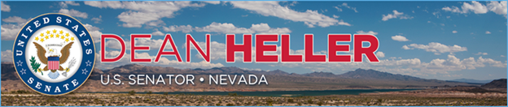

|  |  |
| --- | --- |
| **For Immediate Release:** | **Contact:**[Megan Taylor](mailto:Megan_Taylor@heller.senate.gov) |
| June 5, 2018 | 202-224-6244 |

**Heller Joins President Trump at Signing Ceremony for Bill to Help Nevada’s Young Cancer Patients***Heller is a Cosponsor of the Childhood Cancer STAR Act*

**WASHINGTON** – U.S. Senator Dean Heller (R-NV) today joined President Trump at the signing ceremony for the Childhood Cancer Survivorship, Treatment, Access, and Research (STAR) Act (S.292), bipartisan [legislation cosponsored by Heller to accelerate pediatric cancer research and provide resources for young patients](https://www.heller.senate.gov/public/index.cfm/2018/2/heller-backs-bipartisan-bill-to-fight-childhood-cancers). According to the National Institutes of Health’s (NIH’s) [National Cancer Institute](https://www.cancer.gov/types/childhood-cancers/child-adolescent-cancers-fact-sheet#q1), childhood cancer is the leading cause of death by disease past infancy among children in the U.S.

In April, Johnny Hartman, a childhood cancer survivor from Sparks, NV, [shared his story with Heller](https://www.nvchildrenscancer.org/johnnysactiondays/) and discussed the importance of the STAR Act becoming law. Hartman represented the Northern Nevada Children’s Cancer Foundation (NNCCF) and the state of Nevada in support of the STAR Act. Additionally, the American Cancer Society Cancer Action Network, American Childhood Cancer Organization, and St. Jude Children’s Research Hospital support the legislation.

“I applaud the President for signing into law this important bill that will help researchers and young patients in Nevada fight against pediatric cancers,” **said Heller.** “This new law supports survivors and gives our nation’s top disease fighters the critical resources they need to develop new treatments to save lives. It represents an important step in our battle to put an end to cancers that cut short too many young lives, and I was proud to support it and help send it to the President’s desk.”

**The AllianceForChildhoodCancer.org is quoted on Northern Nevada Children’s Cancer Foundation website saying**, “The Childhood Cancer Survivorship, Treatment, Access, and Research (STAR) Act is the most comprehensive childhood cancer bill ever taken up by Congress. It would expand opportunities for childhood cancer research, improve efforts to identify and track childhood cancer incidences and enhance the quality of life for childhood cancer survivors.”

The Childhood Cancer STAR Act was introduced by U.S. Senators Jack Reed (D-RI) and Shelley Moore Capito (R-WV).

###