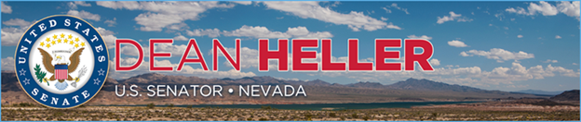

|  |  |
| --- | --- |
| **For Immediate Release:** | **Contact:**[Megan Taylor](mailto:Megan_Taylor@heller.senate.gov) |
| September 21st, 2018 | 202-224-6244 |

**Heller Joins President Trump at VA Southern Nevada Healthcare System for Signing of Bill to Support Nevada Veterans**

*Legislation Includes Heller Provisions to Support Veterans, Increase Accountability at the VA*

**LAS VEGAS** – U.S. Senator Dean Heller (R-NV) today joined President Donald J. Trump as he signed into law the final conference agreement to accompany the Energy and Water, Legislative Branch, and Military Construction and Veterans Affairs appropriations bill (H.R. 5895), which includes Heller’s key provisions designed to support Nevada’s veterans and increase accountability at the Department of Veterans Affairs (VA). In addition to Heller, VA Secretary Robert Wilkie, Nevada Governor Brian Sandoval, Attorney General Adam Laxalt, Director of the VA Southern Nevada Healthcare System Peggy Kearns,Director of the Nevada Department of Veterans Services Katherine Miller, and over 100 Nevada veterans attended the event at the Southern Nevada VA Hospital located in Las Vegas, Nevada.

“This bill signing today marks another veterans victory for Congress, for VA Secretary Wilkie, and for the Trump Administration – passing appropriations legislation to fully fund the VA,” **Heller said.** “I was proud to support this legislation because it invests in our nation’s veterans. What does this bill mean for Nevada? For our military, it means $59 million for Creech Air Force Base, $5.9 million for Nellis Air Force Base, and $32 million for Nevada’s Army National Guard for military construction projects. For our veterans, it means $3 billion for disability claims processing, $1.1 billion for the VA’s electronic health record, $8.6 billion for mental health so we can combat veteran suicides, and $1.8 billion for homeless veteran programs. That includes housing facilities like Veterans Village, run by Dr. Arnold Stalk, that bring veterans in under HUD-VASH vouchers.”

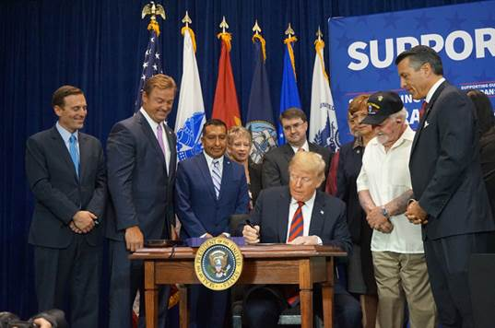

*President Trump signs legislation to support America's veterans and renovate our military bases at the North Las Vegas VA Medical Center.*

“Today I’m honored to be at the North Las Vegas VA Medical Center to sign into law a historic government funding bill that will renovate our nation’s military bases and provide great world class care to our great veterans,” **said President Donald J. Trump**. “I want to thank your state’s great Senator, Dean Heller, he has been so helpful.”

The legislation enacted today includes Heller’s provision to ensure that the VA Caregiver Program has the staffing necessary in Reno, Las Vegas, and across the country to provide the attention and support these veterans and their caregivers deserve. Heller has long worked to see that the VA effectively operates the Caregiver Program, which provides a stipend to family members of severely disabled veterans who provide them with in-home care.

“With this funding bill we’ve increased the VA’s budget to the largest ever. We are delivering the resources needed to fully implement crucial VA reforms,” **said** **President Donald J. Trump**. **He later continued,** “Today’s funding package also delivers for the men and women now serving in uniform. The legislation includes more than $10 billion to build, renovate and repair housing, schools, training centers, and other facilities on military bases. This is terrific news for Nevada’s nearly 20,000 active duty and reserve soldiers, sailors, airmen, marines and national guards. We are providing nearly $100 million for three bases right here in Nevada: Creech Air Force Base, Nellis Air Force Base, and the National Guard right in the center, just a few miles away.”

In addition to ensuring the VA Caregiver Program is effective, Heller has also worked to enhance oversight of the VA’s use of resources devoted to ending veteran homelessness. The legislation signed into law today also includes a provision that Heller authored with U.S. Senate Committee on Veterans’ Affairs Ranking Member Senator Jon Tester (D-MT) to prohibit the VA from transferring any funds out of the VA’s homeless veteran programs.

“As the fifth most bipartisan member of the U.S. Senate and senior member of the U.S. Senate Committee on Veterans Affairs, I was proud to work with my colleagues on both sides of the aisle to send this important legislation to the President’s desk,” **said Heller**. “Nevada is home to over than 300,000 veterans, so it’s fitting to have the President in Las Vegas today to sign this bill among so many Nevadans who bravely served this country. While this bill represents significant progress, we still have work to do and I look forward to continue working together to deliver on our nation’s promise to America’s heroes.”

###

[cid:image003.png@01D451BB.15B0A7A0](http://www.facebook.com/pages/US-Senator-Dean-Heller/325751330177)[cid:image004.png@01D451BB.15B0A7A0](http://twitter.com/SenDeanHeller)[cid:image005.png@01D451BB.15B0A7A0](http://www.youtube.com/user/SenDeanHeller)