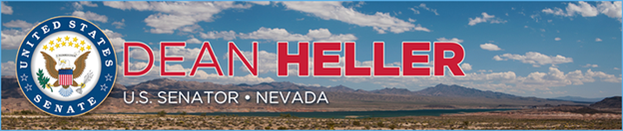

|  |  |
| --- | --- |
| For Immediate Release: | **Contact:** [Megan Taylor](mailto:Megan_Taylor@heller.senate.gov) |
| December 21, 2017 | 202-224-6244 |

**Heller Joins Secretary Zinke As He Initiates First-Ever National Survey of Critical Minerals  
*Action Follows President Trump’s Executive Order to Reduce America’s Reliance on Foreign Nations for Critical Minerals***

**Washington, D.C. –** U.S. Senator Dean Heller (R-NV) today joined U.S. Secretary of the Interior Ryan Zinke as he signed a [secretarial order](https://www.doi.gov/sites/doi.gov/files/uploads/so_criticalminerals.pdf) directing the first nationwide geological and topographical survey of the United States in modern history in order to ultimately reduce America’s reliance on foreign countries for critical minerals that are found in Nevada. Today’s secretarial order follows [a U.S. Geological Survey (USGS) report that found our country depends on China to source 20 out of 23 critical minerals](https://pubs.er.usgs.gov/publication/pp1802) foreign nations for critical minerals and [President Trump’s executive order](https://www.doi.gov/sites/doi.gov/files/uploads/2017minerals.eo_.pdf) to break our nation’s dependence on them.

[Heller has authored the legislation, the National Strategic and Critical Minerals Production Act](https://www.congress.gov/bill/115th-congress/senate-bill/145), that would allow the United States to more efficiently develop our nation's hard rock minerals by streamlining the permitting process for mineral exploration and mine development projects and reducing regulatory red tape. The U.S. permitting process is so broken that it takes on average seven to 10 years to begin operations, whereas in countries like Canada and Australia it only takes about two years to get a permit.

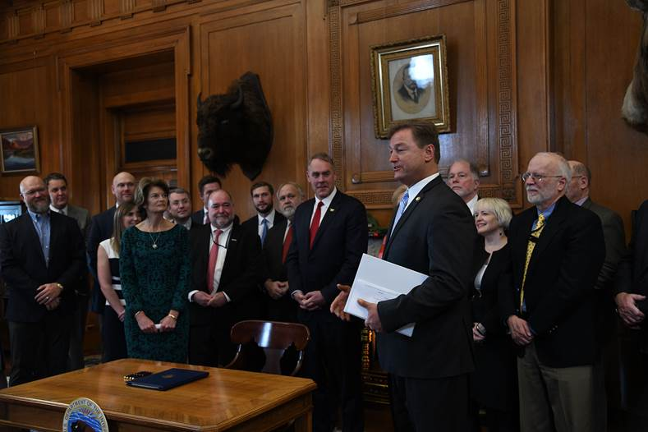

*Heller delivering remarks at today’s signing ceremony at the Department of Interior.*

*\*Media has permission to use image.*

“I applaud Secretary Zinke for initiating a review of the outdated, job-crushing policies that inhibit our ability to utilize our own mineral resources,” **said Heller.** “Nevada is one of the most mineral rich locations on earth, and hard rock mining contributes to thousands of jobs in our state. In order to harness our nation's true mineral potential and end our reliance on foreign production, we need to streamline and update these policies, and that's why I authored legislation that would do just that. I thank Secretary Zinke for his leadership on this issue and his work to help allow Nevada and this country to enact a strategy to fully maximize our nation’s mineral potential.”

“Right now the United States is almost completely reliant on foreign adversaries and competitors for many of the minerals that are deemed critical for our national and economic security. As both a former military commander and geologist, I know the risk this presents to our nation,” **said Secretary Ryan Zinke.** “The problem is we can't fix the problem if we don't know where the minerals are within our own boarders. Other nations are far ahead of us with mapping of their mineral resources, leading to private sector investment overseas rather than right here at home. Drafting a complete topographical and geographic survey of the United States is exactly the kind of task the USGS was created to do.”

Nevada is one of the world’s largest sources of rare earth minerals, producing 20 minerals that are essential to our everyday lives. In addition to producing minerals like copper and lithium that we use to do things like build roads and electric cars, Nevada is responsible for nearly 80 percent of the gold mined domestically and is the 2nd largest producer of silver in the country. According to the Nevada Mining Association, the industry contributes more than $11 billion to Nevada’s economy and accounts for almost 30,000 jobs with an average salary of more than $90,000.

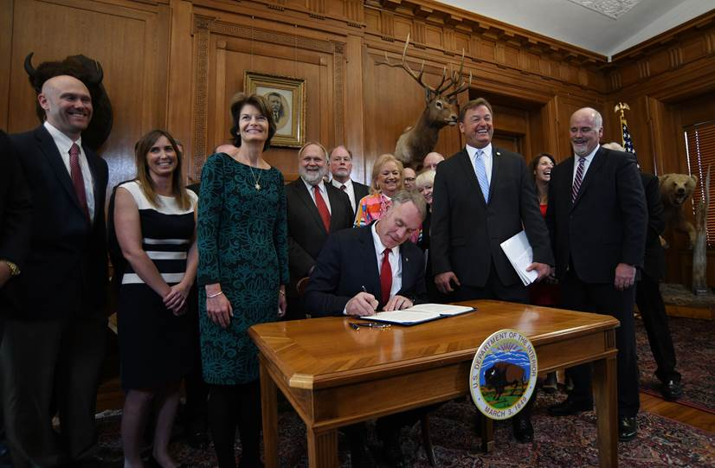

*Secretary Zinke signing the secretarial order.*

*\*Media has permission to use image.*

**###**

[cid:image004.png@01D37A8B.793DC350](http://www.facebook.com/pages/US-Senator-Dean-Heller/325751330177)[cid:image005.png@01D37A8B.793DC350](http://twitter.com/SenDeanHeller)[cid:image006.png@01D37A8B.793DC350](http://www.youtube.com/user/SenDeanHeller)