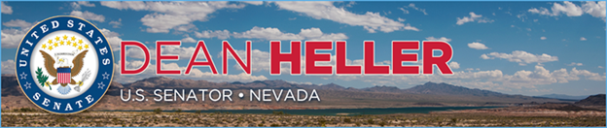

|  |  |
| --- | --- |
| **For Immediate Release:** | **Contact:**[Megan Taylor](mailto:Megan_Taylor@heller.senate.gov) |
| May 9, 2018 | 202-224-6244 |

**Heller Joins Transportation Secretary Elaine L. Chao at Event Announcing the City of Reno, Flirtey as one of the Drone Pilot Integration Program Selectees**

**WASHINGTON**– U.S. Senator Dean Heller (R-NV) joined Department of Transportation (DOT) Secretary Elaine L. Chao today at an event to formally [announce that the City of Reno and Flirtey, a Nevada-based drone delivery service company that is pioneering life-saving applications of drone technologies, for its Federal Aviation Administration (FAA) Unmanned Aircraft Systems (UAS) Integration Pilot Program](https://www.heller.senate.gov/public/index.cfm/pressreleases?ID=CCE90940-D6F0-4B14-9D99-B2106ADBB4B8). FAA Administrator Dan Elwell, Reno Mayor Hillary Schieve, and others joined Heller and Secretary Chao via a live telecast.   
  
Earlier this Spring, [Heller urged Secretary Chao to choose the city of Reno’s application for the highly competitive program](https://www.heller.senate.gov/public/_cache/files/1c2ee359-ef40-4b46-89d8-ef6eda2ff706/04302018%20NV%20Heller%20Cortez%20Masto%20Letter%20to%20Secretary%20Chao%20re%20FAA%20Pilot%20Program%20for%20City%20of%20Reno%20and%20Flirtey.pdf), which allows state, local, and tribal governments to collaborate with private sector entities, such as UAS operators or manufacturers, to help accelerate drone integration into the national airspace system. The DOT received more than 140 applications and only 10, including the City of Reno’s application, were selected.  
  
*“*We have an FAA test site in Nevada run by the Governor’s office, and now we will have another FAA program in the state of Nevada, run by the City of Reno and Flirtey, a Nevada-based drone company,” **said Heller.** “Together with Flirtey, the Mayor and the entire City are seeing beyond the potential of drones to deliver packages to our homes. They see the potential to save lives through delivery of emergency medical supplies. It will be transformational for our urban and rural areas. That is why I am thrilled that Reno, Flirtey, and other team members were picked for this pilot program.”

*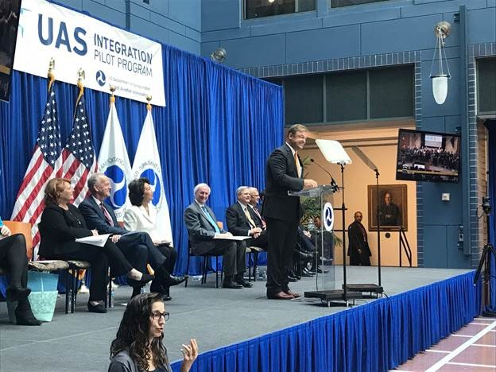  
Heller joins Transportation Secretary Chao to announce the City of Reno was selected for a highly competitive federal drone pilot program.*

“This is such an exciting day for aviation, for safety, for innovation, and I am so pleased to be here today as we unveil the 10 projects selected for the Department’s UAS Integration Pilot Program,” **Secretary Chao remarked at the event**. “Our country is on the verge of the most significant new development in aviation since the beginning of the jet age. The emergence of the unmanned aircraft systems, or drones, the rules and regulations governing our national airspace has really never anticipated drones before. As of May 4th 2018, there were 1.1 million registered drones in the United States, and more than 90,000 registered drone operators. But we’ve got to create a path forward for the safe integration of drones if our country is to remain a global aviation leader, and reap the safety and economic benefits that drone have to offer. That is why on October 25, 2017, the President directed the Department to launch a new pilot program, the Unmanned Aircraft Systems Integration Pilot Program.”

**Background**:

The following Heller provisions were included in the Committee-passed FAA Reauthorization Act of 2017:

* **UAS Test Sites and Authorizing Beyond Line-of-Sight Operations:** Since Nevada is one of the seven UAS test site locations, it will drive drone-related technological research and economic growth statewide. Sec. 2122 include Heller’s priorities to ensure the UAS [test sites](http://diversifynevada.com/key-industries/aerospace-defense/uav), including Nevada’s, are extended beyond 2019 and that the FAA engages the test sites in projects to test, research, and evaluate beyond line-of-sight operations.
* **Small UAS Package Delivery:**The Heller-Cantwell UAS carriage provision in Sec. 2136 directs the Department of Transportation (DOT) to establish a streamlined air carrier certification program tailored for unmanned aircraft systems carrying property, like packages.

During the 114th Congress:

* When the Senate FAA bill came to the floor in the 114th Congress, Senator Heller teamed up with Senator Hoeven on an amendment (S.Amdt.3500 to H.R.636) to ensure the UAS test sites authorizations were extended for a longer period. Heller, along with Hoeven and several colleagues, secured passage of this provision in the FAA Extension, Safety, and Security Act of 2016 (P.L.114-190) that was signed into law on July 15, 2016.

###

[cid:image002.png@01D4707F.057F3FD0](http://www.facebook.com/pages/US-Senator-Dean-Heller/325751330177)[cid:image003.png@01D4707F.057F3FD0](http://twitter.com/SenDeanHeller)[cid:image004.png@01D4707F.057F3FD0](http://www.youtube.com/user/SenDeanHeller)