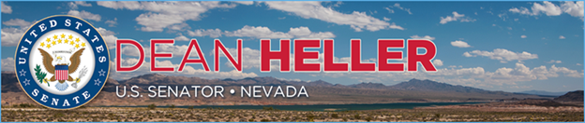

|  |  |
| --- | --- |
| **For Immediate Release:** | **Contact:** [Megan Taylor](mailto:Megan_Taylor@heller.senate.gov) |
| April 4, 2018 | 202-224-6244 |

**Heller Joins U.S. Transportation Secretary Elaine L. Chao to Announce $7.5 Million Grant for Carson City, Additional Funding for Nevada**

**CARSON CITY, NV** –  U.S. Senator Dean Heller (R-NV) today joined U.S. Secretary of Transportation Elaine L. Chao, Mayor Bob Crowell, and other state and local elected officials in Carson City, NVat an event to officially announcethe $7.5 million grant to complete the South Carson Street project.

In October 2017, Heller urged Secretary Chao to support the South Carson Street project, noting that it will “drive economic growth and investment directly into the heart of our state capital.” Last month, the U.S. Department of Transportation (DOT) awarded $7,570,202.00 to the Carson City Public Works Department through the Department’s highly competitive Transportation Investment Generating Economic Recovery (TIGER) grant program.

“This federal funding is critical to building upon the city’s downtown revitalization by linking downtown and the commercial corridor via a cohesive and continuous complete streets design. This will help the city improve pedestrian safety and mobility in the area. It will also increase access to small businesses along the corridor,” **said Heller**. “It’s important that this city has the resources it needs to support local transportation and growth. So thank you for choosing us, Secretary Chao. Thank you for recognizing Carson City’s needs and for making the $7.5 million grant for my hometown a reality.”

At the event, Heller also announced additional grants awarded by DOT. Heller said that the Carson Area Metropolitan Planning Organization will receive an additional $447,480.00 in funding to replace two buses in the “Jump Around Carson” fleet that have exceeded their useful life. He also announced the Pyramid Lake Paiute Tribe will receive $1.5 million in grant funding through the Bus and Bus Facilities Competitive Program for a new facility. Lastly, Heller said the Southern Nevada Regional Transportation Commission will receive $4.5 million in grant funding for construction and improvement of bus shelters down south.

“This project demonstrates the importance of cooperation between the Federal government and state and local governments,” **said Secretary Chao.** “Local government is a natural partner in infrastructure.”

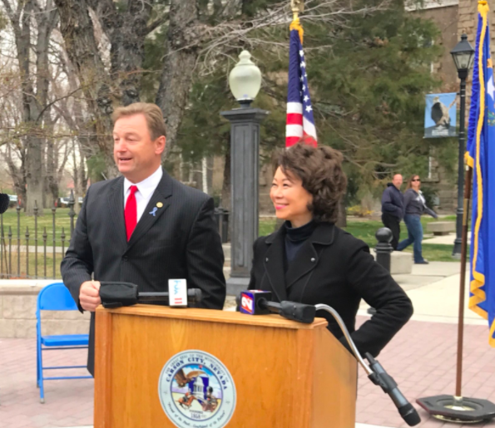

*Secretary Chao and Senator Heller discuss the importance of the $7.5 million grant to Carson City*

In his remarks, Heller noted that Nevada was the fastest growing state in the 2000s, and last year - Nevada led the nation in private sector job growth. “States like Nevada that have experienced an unprecedented amount of growth over the past several decades have the most to gain from this Administration’s push to upgrade our aging infrastructure,” **added Heller.** “Nevada has a great partner in Secretary Chao. As a member of three U.S. Senate committees with jurisdiction over infrastructure, I’m grateful to have the opportunity to work with her to advance Nevada’s priorities.”

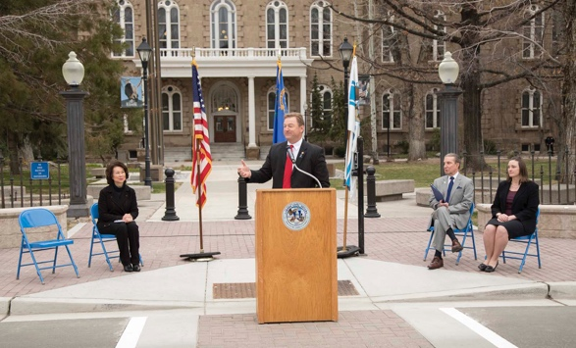

*Senator Heller speaks to attendees about the South Carson Street project*

**Background**:

The South Carson Street Complete Streets project will construct an approximately 2.5 mile complete streets corridor, including a corridor-wide road diet, a roundabout, a multiuse path, dedicated bicycle facilities, pedestrian safety improvements, storm water infrastructure, and fiber-optic communications infrastructure to support intelligent transportation systems (ITS).

The project will turn a high-crash corridor into a safer facility for all users by reducing speeds and enhancing pedestrian and bicycle facilities. The new multimodal facilities also will provide improved transportation choices for area residents. The installation of fiber optic lines along with the road construction project is a first step towards advancing Carson City as a Smart City.

This year, the Department received 452 eligible applications for TIGER grants. Carson City is one of 41 recipients of nearly $500 million in discretionary grant funding for road, transit, maritime and rail projects across the country.

Hellersupported funding for the TIGER grant program with the passage of Public Law 114-113, which allocated $500 million to the TIGER program to remain available through fiscal year 2019. He also supported the government spending measure, which was recently signed into law, that allocated $1.5 billion to the TIGER program.

###