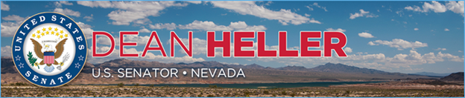

|  |  |
| --- | --- |
| **For Immediate Release:** | **Contact:**[Megan Taylor](mailto:Megan_Taylor@heller.senate.gov) |
| October 10, 2018 | 202-224-6244 |

**Heller Measure to Secure Funding for Truckee Meadows Flood Control Project Now Heads to President’s Desk**

*Provision Included U.S. Senate-Passed Water Infrastructure Bill*

**WASHINGTON –** The U.S. Senate today approved the America’s Water Infrastructure Act, legislation that includes a provision secured by U.S. Senator Dean Heller (R-NV) to authorize the Truckee Meadows Flood Control Project at $181 million in federal funding. The measure is now headed to the President’s desk, where it is expected to be signed into law.

Specifically, the Truckee Meadows Flood Control project is an initiative designed to reduce the potential destruction of a 100-year flood. With Heller’s strong support, the Water Resources Reform and Development Act was signed into law in 2014, and it included a provision to authorize federal funds toward the Truckee Meadows Flood Control Project. In order to ensure that this funding would not be jeopardized, [Heller worked with the U.S. Senate Environmental and Public Works Committee](https://www.heller.senate.gov/public/index.cfm/pressreleases?ID=2BC65282-FB32-4DB5-BDE1-87DB117353BD) to protect the authorization of the project. Heller’s letter to Chairman John Barrasso (R-WY) can be found [HERE](https://www.heller.senate.gov/public/_cache/files/c8f52b76-6d84-4c4c-8c74-fc195ff1c48b/Heller%20Letter%205.18.18.pdf).

“The Truckee Meadows Flood Control Project is a critical local effort that will help mitigate the threat of flash floods throughout Northern Nevada, which have the potential to devastate the infrastructure of our homes, businesses, and roads and bridges,” **said Heller.** “I realize how important this project is for our community being from Northern Nevada myself, which is why I worked to secure funding for it in the reconciled water infrastructure legislation. I look forward to continue working with my colleagues to ensure that this legislation is signed into law, providing the Truckee Meadows Flood Control Project with the promised $181 million in federal funding.”

###

[cid:image002.png@01D46092.A48CCE50](http://www.facebook.com/pages/US-Senator-Dean-Heller/325751330177)[cid:image003.png@01D46092.A48CCE50](http://twitter.com/SenDeanHeller)[cid:image004.png@01D46092.A48CCE50](http://www.youtube.com/user/SenDeanHeller)