

|  |  |
| --- | --- |
| **For Immediate Release:** | **Contact:**[Megan Taylor](mailto:Megan_Taylor@heller.senate.gov) |
| July 19, 2018 | 202-224-6244 |

**Heller Meets with U.S. Supreme Court Justice Nominee Judge Brett Kavanaugh**

**WASHINGTON –**U.S. Senator Dean Heller (R-NV) today released the below statement following his meeting with Judge Brett Kavanaugh, President Trump’s nominee to serve on the U.S. Supreme Court:   
  
“Today, I had the opportunity to sit down with Judge Brett Kavanaugh to ask him questions about his record, learn more about his judicial philosophy, and discuss his approach to serving on our nation’s highest court,” **said U.S. Senator Dean Heller (R-NV).**“With more than a decade of experience serving on the second most powerful court in the country and as the author of more than 300 opinions, Judge Kavanaugh has an extensive record that reflects a clear respect for precedent. He is a mainstream jurist who has proven that he is dedicated to defending the Constitution and upholding the rule of law – not re-writing it from the bench. His legal career combined with his educational credentials make him an exceptionally qualified nominee to fill the upcoming vacancy on the U.S. Supreme Court. At this point, I have no reservations in confidently supporting Judge Kavanaugh’s confirmation.”

*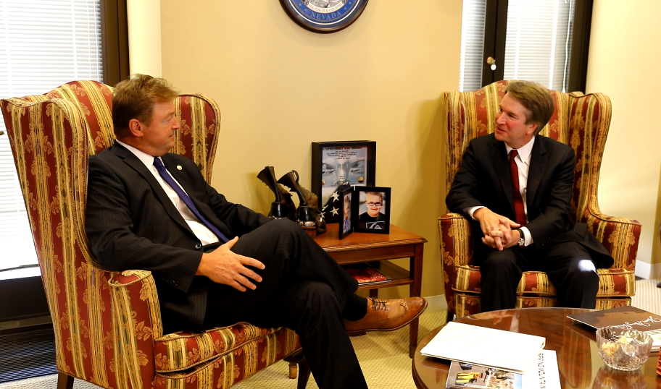  
Senator Heller and Judge Kavanaugh meet in Senator Heller’s office. *Media has permission to use.*

Judge Brett Kavanaugh has served on the U.S. Court of Appeals for the District of Columbia Circuit since 2006. Prior to his appointment to the circuit court, Judge Kavanaugh clerked for retiring Supreme Court Justice Anthony Kennedy and he also served as Senior Associate Counsel to President George W. Bush. He received his bachelor’s degree from Yale University and he graduated from Yale Law School, where he was the Notes Editor for the Yale Law Journal, in 1990.

[cid:image005.png@01D41926.8854AF90](http://www.facebook.com/pages/US-Senator-Dean-Heller/325751330177)[cid:image006.png@01D41926.8854AF90](http://twitter.com/SenDeanHeller)[cid:image007.png@01D41926.8854AF90](http://www.youtube.com/user/SenDeanHeller)