

|  |  |
| --- | --- |
| **For Immediate Release:** | **Contact:** [Megan Taylor](mailto:Megan_Taylor@heller.senate.gov) |
| May 26, 2017 | 202-224-6244 |

**Heller Releases Message Ahead Of Memorial Day   
*We Owe A Debt That Can Never Fully Be Repaid***

**Washington, D.C** – In honor of Memorial Day, U.S. Senator Dean Heller (R-NV) released a video commemorating this important holiday and recognizing its heartfelt purpose of honoring our fallen heroes. Click [HERE](https://www.youtube.com/watch?v=blFuT8Ij9Lk&feature=youtu.be) or below to watch.

[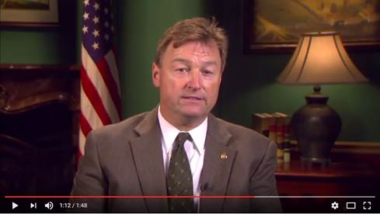](https://www.youtube.com/watch?v=blFuT8Ij9Lk&feature=youtu.be)  
[Click [here](https://www.youtube.com/watch?v=blFuT8Ij9Lk&feature=youtu.be) or the above image to watch]

###

[cid:image002.png@01D2CB49.FB1F9D90](http://www.facebook.com/pages/US-Senator-Dean-Heller/325751330177)[cid:image003.png@01D2CB49.FB1F9D90](http://twitter.com/SenDeanHeller) [cid:image004.png@01D2CB49.FB1F9D90](http://www.youtube.com/user/SenDeanHeller)