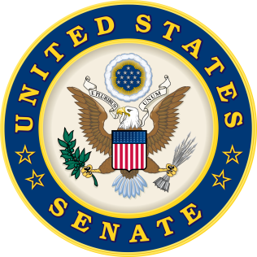
For Immediate Release: | Contacts:
April 28, 2015 | Neal A. Patel/Michawn Rich 202-224-6244 (Heller)
 | Kerry Arndt 202-224-2834 (Murray)

Heller, Murray Reintroduce Bill to Assist Children of Veterans
(Washington, DC) – Today, U.S. Senators Dean Heller (R-NV) and Patty Murray (D-WA) introduced the Creating A Reliable Environment (CARE) for Veterans’ Dependents Act, a bill designed to ensure children of homeless veterans are also eligible for services provided to that veteran by VA-funded facilities.
“As I’ve said before, America’s commitment to providing a strong defense doesn’t end on the battlefield. It extends to ensuring our veterans are properly taken care of when they return home after service. When veterans and their dependents fall on tough times, community agencies providing services to them should be reimbursed by the VA,” said Senator Dean Heller. “I am proud to re-introduce this important legislation with Senator Murray.”
“America’s veterans and their families often face unprecedented challenges long after their service is over,” said Senator Patty Murray. “It would be unacceptable to turn our backs on our military families in their time of need, which is why I’m proud to support this legislation. It reinforces our commitment to care for the men and women who bravely served our country.”
Background:
- Under current law, the VA Grant and Per Diem program does not reimburse VA-funded facilities for services provided to a homeless veteran’s dependent.
- Children accompanying their veteran parent who has fallen on hard times should be able to receive care at these VA-funded facilities.
- The CARE for Veterans’ Dependents Act simply allows the VA to reimburse facilities for care of a dependent of a veteran receiving care at a shelter funded by the VA Grant and Per Diem program.
A PDF copy of the CARE for Veterans’ Dependents Act is attached with this release.

###

