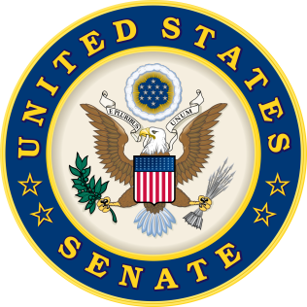
For Immediate Release  February 10, 2017 | Contacts:  Neal A. Patel 202-224-6244 (Heller)

Senate Travel & Tourism Caucus Welcomes New Co-Chair Senator Dean Heller

(Washington DC) –Recently, U.S. Senator Dean Heller (R-NV) was announced as the newest co-chair of the Senate Travel and Tourism Caucus. He will co-chair the caucus with Senators Roy Blunt (R-MO), Amy Klobuchar (D-MN), and Brian Schatz (D-HI). The Travel and Tourism Caucus works to promote common-sense policies and raise awareness of the importance of the job-creating travel and tourism industry.

“With over 55 million visitors coming to Nevada annually, the positive impact of the travel and tourism industries to Nevada cannot be overstated,” said Senator Dean Heller. “Nearly half a million jobs are supported through tourism with our state becoming a premier destination with its world-renowned facilities and top notch services. I look forward to working with my fellow caucus co-chairs and utilizing my role on the influential Senate Committees on Commerce, Banking, and Finance to advance policies that promote travel to Nevada and across the country.”

“Sen. Heller has been a leader in advocating for the travel and tourism industry and the millions of American jobs it supports,” said Senator Roy Blunt. “He was instrumental in getting the Travel Promotion, Enhancement, and Modernization Act signed into law in 2014, and I look forward to working with him to continue advancing policies that will strengthen and grow the tourism industry in Missouri and across the nation.”

“As co-chair of the Senate Travel and Tourism Caucus, I know how important travel and tourism are to the economy of Minnesota and our country,” said Senator Amy Klobuchar. “I look forward to continuing to work with Senators Blunt, Schatz, and Heller to boost the U.S. tourism industry and the many jobs it supports.”

“I’m happy to have Senator Heller onboard, and I look forward to working with him,” said Senator Brian Schatz. “Tourism creates jobs and supports thousands of small businesses in Hawaii and across the country. That’s why we need to continue to work on a bipartisan basis to create policies that will help grow our tourism industry and our economy.”

According to the U.S. Travel Association, America’s travel and tourism industry generates $2.1 trillion in economic output, supports over 15 million jobs, and generates over $147 billion in revenue for federal, state, and local government.

###

