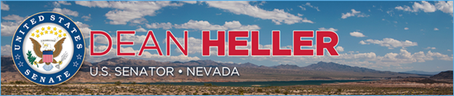

|  |  |
| --- | --- |
| **For Immediate Release:** | **Contact:** [Megan Taylor](mailto:Megan_Taylor@heller.senate.gov) |
| January 24, 2018 | 202-224-6244 |

**Heller: Nevada Has Been a Leader in Driverless Technologies**

**WASHINGTON, D.C.** – During a U.S. Senate Commerce, Science and Transportation Committee hearing this morning that examined policies related to innovation in the automotive industry, U.S. Senator Dean Heller (R-NV) questioned a witness about ways self-driving cars could help reduce the number of traffic fatalities, particularly in rural areas, and noted how Nevada has been a leader in driverless technologies. Watch the clip [HERE](https://youtu.be/znKZpPaLgQs).

[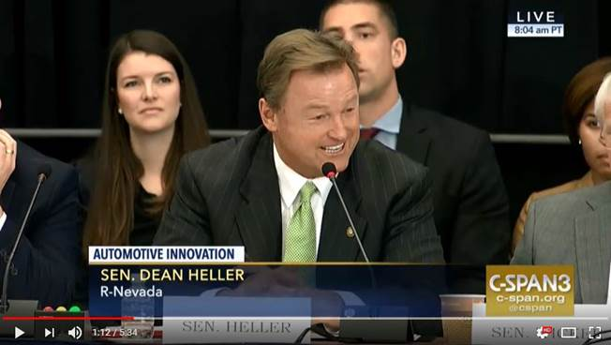](https://www.youtube.com/watch?v=znKZpPaLgQs&feature=youtu.be)

Click [HERE](https://youtu.be/znKZpPaLgQs) to watch the video.

**Background:**

In 2011, Nevada became the first state to pass autonomous vehicle legislation that paved the way for testing. Since then, autonomous cars, semi-trucks, and buses have all been tested in the state. To build on this success, Nevada passed legislation for full-implementation of autonomous vehicles for commercial use. The Silver State is also home to automotive manufacturer Tesla, which is developing an autonomous vehicle and produces electric vehicles.

**###**

[cid:image004.png@01D39523.F2CAD750](http://www.facebook.com/pages/US-Senator-Dean-Heller/325751330177)[cid:image005.png@01D39523.F2CAD750](http://twitter.com/SenDeanHeller)[cid:image006.png@01D39523.F2CAD750](http://www.youtube.com/user/SenDeanHeller)