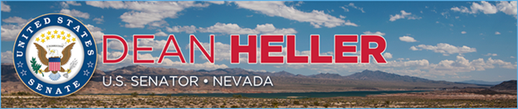

|  |  |
| --- | --- |
| For Immediate Release: | **Contact:** [Megan Taylor](mailto:Megan_Taylor@heller.senate.gov) |
| December 22, 2017 | 202-224-6244 |

**Heller on President’s Move to Sign Tax Relief Bill Into Law: “Today is a Good Day for Nevadans and Americans Everywhere”**

***In Video, Heller Highlights Benefits of Tax Relief Bill for Nevadans***

**Washington, D.C. –** U.S. Senator Dean Heller (R-NV), a member of the tax-writing Senate Finance Committee, today applauded President Trump for signing into law the Tax Cuts and Jobs Act. This legislation will provide critically important tax cuts to Nevada’s middle-class families, boost job creation, and spur economic growth in our communities. It also eliminates Obamacare’s individual mandate tax penalty, which will help the tens of thousands of Nevadans who would otherwise be forced to pay the fine.

According to the independent Tax Foundation, this legislation is expected to give a typical Nevada family of four a tax cut of approximately $2,200. Additionally, the non-partisan Joint Committee on Taxation recently confirmed that every income category of Nevada’s roughly 1.4 million individual tax return filers will receive a tax cut.

“I applaud the President for acting swiftly to sign into law tax relief legislation that will take effect January 1, 2018 because Nevadans can’t wait any longer for tax cuts,” **said Heller**. “Americans are already feeling the positive impact of this bill given that immediately after its passage, several companies announced they plan to increase wages and give their employees bonuses. This bill will provide much-needed tax cuts to Nevada’s middle-class families, and I encourage all Nevadans to compare their paychecks today to the ones they’ll receive in February; they’re going to be bigger because our bill allows them to keep more of their hard-earned money. This is particularly important at a time when nearly 8 in 10 Americans who work full-time are living paycheck to paycheck, Nevadans real median household income is down $7,000 from 10 years ago, and at a time when the cost of housing and childcare expenses continue to skyrocket.”

The legislation includes an amendment that Heller filed with Sen. Tim Scott (R-SC) to [increase the child tax credit to $2,000](https://www.heller.senate.gov/public/index.cfm/pressreleases?ID=ADAE007F-013A-4ADE-B306-8BF1465069EC), or double it from current law. It also includes Heller’s measure to make it easier for startups and [businesses to give employees an ownership stake in their company’s success](https://www.heller.senate.gov/public/index.cfm/pressreleases?ID=42F977DB-BFAF-4668-81AD-AD805E5128E8)by awarding stock options. Additionally, Heller was able to protect the tax exemption for stadium bonds, which is critical to preserving the influx of business and growth associated with the construction of the Raiders stadium in Las Vegas, NV.

**Heller added,** “Nevadans have been waiting for a break, and this is it. For example, this bill includes my provision to double the child tax credit from current law, reduces rates on lower-income and middle-class families, and provides relief to tens of thousands of Nevadans by eliminating Obamacare’s individual mandate tax penalty. From bringing Secretary Mnuchin to Nevada to hear directly from my constituents to working closely with Ivanka Trump to increase the child tax credit, I’ve made sure that Nevadans voices were heard by the Administration and my colleagues as we worked with the White House to put together and pass the first tax relief package in more than 30 years. Today is a good day for Nevadans and Americans everywhere.”

In the below [video](https://www.youtube.com/watch?v=sTmzBfK7_RE&feature=youtu.be), Heller highlights how the tax relief legislation will benefit Nevadans. You may watch the video by clicking [HERE](https://www.youtube.com/watch?v=sTmzBfK7_RE&feature=youtu.be) or on the below image.

[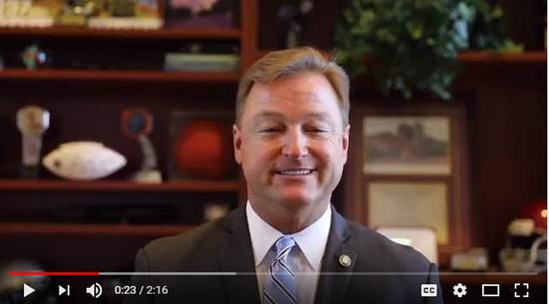](https://www.youtube.com/watch?v=sTmzBfK7_RE&feature=youtu.be)

[Click [HERE](https://www.youtube.com/watch?v=sTmzBfK7_RE&feature=youtu.be) or on the above image to view the video]

**Transcript**:

*Hi, I’m Senator Dean Heller, and I’m proud to report that with my help, Congress just sent a tax relief bill to the President’s desk for the first time in more than 30 years.*

*Whether it’s the single mother in Gardnerville who works full-time or the ambitious entrepreneur in Reno who started a business while going to school, Nevadans throughout the state will benefit from the passage of this historic legislation.*

*This bill will provide much-needed tax cuts to Nevada’s middle-class families, jumpstart job creation, and drive growth in communities throughout our state.*

*This is particularly important at a time when nearly 8 in 10 Americans who work full-time are living paycheck to paycheck.*

*At a time when Nevadans real median household income is down $7,000 from 10 years ago.*

*And at a time when the cost of housing and childcare expenses continue to skyrocket.*

*That’s why I’m proud that this bill includes my provision to double the child tax credit from current law.*

*It also reduces rates on lower-income and middle-class families.*

*And it eliminates Obamacare’s individual mandate tax penalty.*

*This will give tens of thousands of Nevadans the break that they deserve after Washington bureaucrats forced them to pay a fine for not buying a product that they likely couldn’t afford.*

*The bottom line is this: our bill will allow you to keep more of your paycheck.*

*In fact, every income category of Nevada’s roughly 1.4 million individual tax return filers will receive a tax cut.*

*To put that into perspective, this bill is expected to give a typical Nevada family of four a tax cut of about $2,200.*

*As the son of a school cook and an auto mechanic, I was told that if you work hard and play by the rules then anything is possible.*

*But the problem today is that too many people think that isn’t the case anymore.*

*This bill changes that by empowering families and restoring their faith in the American dream, and I’m proud to have worked with my colleagues on the tax-writing committee, the White House, and Administration officials to get it over the finish line.*

*Nevadans and Americans around this country will be better off because of it.*

**###**

[cid:image003.png@01D37989.90DD50A0](http://www.facebook.com/pages/US-Senator-Dean-Heller/325751330177)[cid:image004.png@01D37989.90DD50A0](http://twitter.com/SenDeanHeller)[cid:image005.png@01D37989.90DD50A0](http://www.youtube.com/user/SenDeanHeller)