

|  |  |
| --- | --- |
| **For Immediate Release:** | **Contact:**[Megan Taylor](mailto:Megan_Taylor@heller.senate.gov) |
| May 14, 2018 | 202-224-6244 |

**Heller on the Opening of the U.S. Embassy in Jerusalem: “Today We are Righting a Wrong”**

**WASHINGTON** – U.S. Senator Dean Heller (R-NV), who attended the opening ceremony celebration of the U.S. embassy in Jerusalem today, said that the United States is finally “righting a wrong” by fulfilling a decades-old promise. [Heller, who joined U.S. Senators Lindsey Graham (R-SC), Ted Cruz (R-TX), and Mike Lee (R-UT) to observe the opening of the United States Embassy in Jerusalem](https://www.heller.senate.gov/public/index.cfm/pressreleases?ID=15F5484C-9A5A-4C7E-9F43-110DEBC4B624), will return to the United States this evening.   
  
In addition to the opening ceremony, the Senators met with Israeli Prime Minister Benjamin Netanyahu and senior Israeli government officials regarding counter-terrorism and national security issues affecting the United States and Israel. They also discussed the strong U.S.-Israeli alliance with Ivanka Trump and members of the White House delegation who attended the ceremony.  
  
“Today is a day of celebration for the United States and Israel, two nations that are now joined closer together. The United States is finally righting a wrong and fulfilling its decades-old promise by relocating the American embassy to Jerusalem. As the author of legislation that would do just that, I’m humbled to witness this ceremony,” **said Heller.** “While in Jerusalem, our group had the opportunity to meet with Prime Minister Benjamin Netanyahu, U.S. Ambassador to Israel David M. Friedman, and Ivanka Trump to discuss our strong partnership with Israel. Our friend and ally deserves our unwavering support, and today we reaffirmed our commitment to Israel and strengthened our alliance.”

*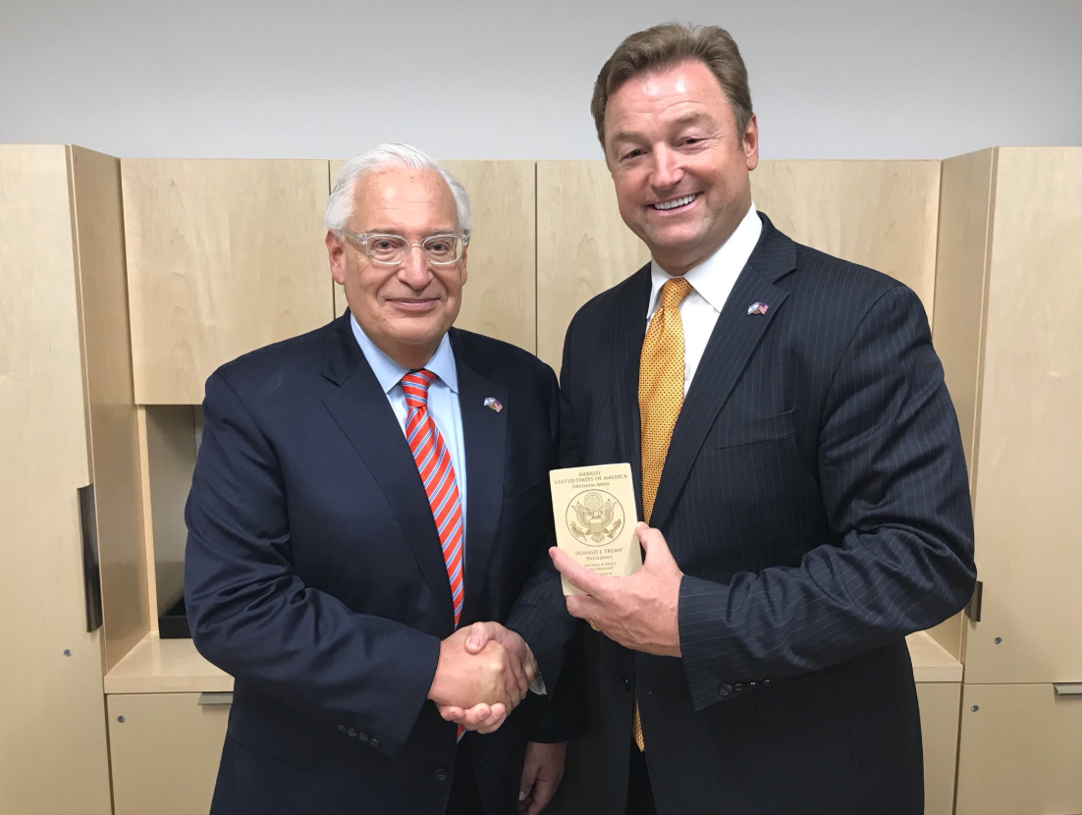  
Heller and U.S. Ambassador to Israel, David M. Friedman.  
*Media has permission to use.*  
  
*

*Heller, group of Senators, Ivanka Trump, and Jared Kushner.  
*Media has permission to use.*  
  
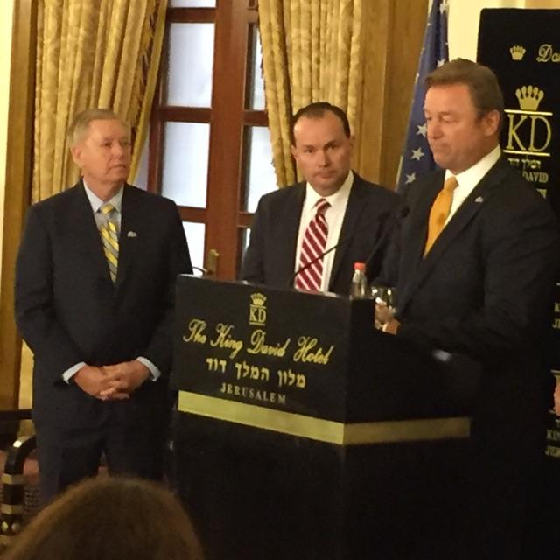  
Heller with Senators Lindsey Graham (left) and Mike Lee (middle) at the Sunday press conference.  
*Media has permission to use.\**

In 1995, Congress passed legislation that recognized Jerusalem as the capital of Israel by moving the U.S. Embassy from Tel Aviv to Jerusalem. However, although the bill became law later that year, the U.S. Embassy was never moved to Jerusalem. In December of 2017, President Trump formally recognized Jerusalem as the capital of Israel and [announced that the Administration would develop a plan to relocate the U.S. embassy to Jerusalem](https://www.heller.senate.gov/public/index.cfm/pressreleases?ID=89936C1E-D142-4F37-8C9A-9546F84277D8).  
  
Heller has long supported relocating the U.S. embassy from Tel Aviv to Jerusalem. He has repeatedly introduced [the Jerusalem Embassy and Recognition Act](https://www.heller.senate.gov/public/index.cfm/pressreleases?ID=15329846-E3DD-46F0-A16E-784700B8358B), legislation that would fulfill our commitment to moving the embassy by requiring the U.S. Department of State to do so or face a penalty.

###

[cid:image002.png@01D4707F.057F3FD0](http://www.facebook.com/pages/US-Senator-Dean-Heller/325751330177)[cid:image003.png@01D4707F.057F3FD0](http://twitter.com/SenDeanHeller)[cid:image004.png@01D4707F.057F3FD0](http://www.youtube.com/user/SenDeanHeller)