

|  |  |
| --- | --- |
| **For Immediate Release:** | **Contact:**[Megan Taylor](mailto:Megan_Taylor@heller.senate.gov) |
| April 19, 2018 | 202-224-6244 |

**Heller Questions CMS Official on his Electronic Prescribing Bill**

**WASHINGTON**– During a U.S. Senate Finance Committee hearing on tackling drug abuse in America, U.S. Senator Dean Heller (R-NV) today asked the Centers for Medicare & Medicaid Services (CMS) how electronic prescribing in Medicare could help address the country’s opioid epidemic. Heller coauthored the [Every Prescription Conveyed Securely Act](https://www.heller.senate.gov/public/index.cfm/2018/2/heller-bennet-introduce-bill-to-combat-opioid-crisis), bipartisan legislation that aims to reduce drug diversion and fraud by requiring electronic prescribing in Medicare. Watch the clip [**HERE**](https://youtu.be/Jtmb73p99Hk).  
  
In response to Heller’s question, Kimberly Brandt, principal deputy administrator for operations at CMS, said that e-prescribing was one of the top issues discussed during multiple stakeholder sessions held by CMS, and the agency believes the data from e-prescribing “has a lot of benefits for plans, pharmacies, prescribers and the states.” [Heller submitted a letter for the record signed by 20 different organizations](https://www.heller.senate.gov/public/_cache/files/86ad2899-93a3-4362-9104-6bf36d87aa83/EPCS%20Act%20Letter%20of%20Support_Senate_April%202018.pdf), including America’s Health Insurance Plans, CVS Health, the National Consumers League, and others urging passage of his bill.

[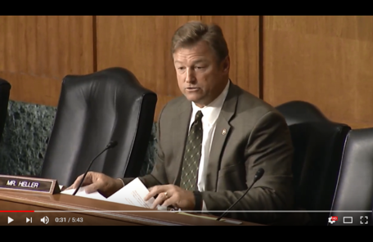](https://youtu.be/Jtmb73p99Hk)  
Click [HERE](https://youtu.be/Jtmb73p99Hk) or the image above to play the video.

In Nevada, 665 people died from drug overdose in 2016, according to the latest data available from the [Centers for Disease Control and Prevention](https://www.cdc.gov/nchs/pressroom/states/nevada/nevada.htm) (CDC). Further, [Nevada’s drug overdose mortality rate stands at 21.7 percent](https://www.cdc.gov/nchs/pressroom/states/nevada/nevada.htm), higher than the national average of 19.8 percent.   
  
The hearing comes as Heller announced that he’s cosponsored sweeping legislation to improve the federal response to Nevada’s drug epidemic. Specifically, [the Opioid Crisis Response Act](https://www.heller.senate.gov/public/index.cfm/pressreleases?ID=3F004D3E-3581-408F-A143-B62C16AE9B27) will improve the ability of the U.S. Departments of Education, Labor, and Health and Human Services to address the crisis, including the ripple effects of the crisis on children, families, and communities, and improve data sharing between states. It reauthorizes grants to states for drug prevention and treatment and also improves detection and seizure of illegal deadly drugs through stronger FDA and Customs and Border Protection coordination.  
  
Heller has a long history of supporting legislation to confront Nevada’s drug problem. Last month he also [helped introduce a bill to strengthen penalties for fentanyl](https://www.heller.senate.gov/public/index.cfm/2018/3/heller-helps-introduce-bill-to-crack-down-on-fentanyl-traffickers) distribution and trafficking to ensure they better reflect the serious nature of the crime.

###

[cid:image002.png@01D46D6A.F79CB3F0](http://www.facebook.com/pages/US-Senator-Dean-Heller/325751330177)[cid:image003.png@01D46D6A.F79CB3F0](http://twitter.com/SenDeanHeller)[cid:image004.png@01D46D6A.F79CB3F0](http://www.youtube.com/user/SenDeanHeller)