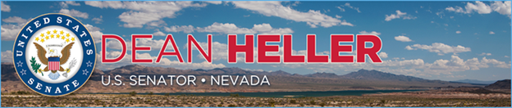

|  |  |
| --- | --- |
| **For Immediate Release:** | **Contact:**[Megan Taylor](mailto:Megan_Taylor@heller.senate.gov) |
| September 18th, 2018 | 202-224-6244 |

**Heller Receives U.S. Wind Champion Award**

**WASHINGTON**– U.S. Senator Dean Heller (R-NV) today received the U.S. Wind Champion Award from the American Wind Energy Association (AWEA) for his work to promote wind energy.

Heller is a long-time supporter of the wind energy industry, and he believes that renewable energy is an integral component of our nation’s all-of-the-above energy strategy. For example, [Heller is the author of the Public Land Renewable Energy Development Act, bipartisan legislation that aims to increase the production of wind, solar, and geothermal energy by streamlining the permitting process for these projects on federal lands](https://www.heller.senate.gov/public/index.cfm/2017/2/bipartisan-group-of-senators-re-introduce-legislation-to-streamline-permitting-for-renewable-energy-projects). Given that around 85 percent of Nevada’s lands are administered by the federal government, the Public Land Renewable Energy Development Act would help renewable energy companies compete on a level playing field. Additionally, Heller successfully fought to protect the 2015 PATH Act deal for wind and solar during tax reform and extend the production tax credit (PTC) and investment tax credit (ITC) to a number of other alternative energy technologies in the Bipartisan Budget Act.

“As a strong advocate for wind energy and the renewable energy industry, I am honored to receive the Wind Champion Award from the American Wind Energy Association,” **said Heller.** “Nevada is home to more than 21,800 renewable energy jobs, and over 23 percent of our state’s total electricity generation comes from renewable sources. Our state continues to be at the forefront of national efforts to harness this country’s renewable energy potential, and that’s why I have consistently worked to advance policies – like the production and investment tax credits – that support Nevada’s energy diversification and the jobs and economic growth that come with it. Whether it’s streamlining the permitting process for wind energy projects on federal lands or creating a level playing field for renewable energy technologies, I am committed to championing solutions that will enhance our nation’s clean energy production as part of an all-of-the-above energy strategy because I believe that renewable energy is Nevada’s – and this country’s – future.”

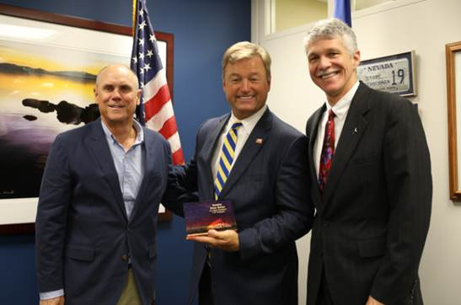

*Sen. Heller receives the Wind Champion Award from the American Wind Energy Association.*

*Media has permission to use this photograph*

“Senator Heller has been a staunch supporter of renewable energy and was instrumental in helping our Spring Valley project become Nevada’s first wind farm,” **said Mike Garland, CEO of Pattern Energy.** “Nevada's leadership in renewable innovation will support a bright future for wind energy in the U.S."

Pattern Energy is responsible for the development of the Spring Valley Wind Project. The facility, which is located 30 miles from Ely, Nevada, is the first wind-fueled power plant on public lands and Nevada’s first utility-scale wind project. The 151.8-megawatt, 66-turbine wind farm generates enough electricity to power approximately 45,000 homes in Nevada.

“Senator Heller is a longstanding champion of wind power and its economic benefits,” **said Tom Kiernan, CEO of AWEA**. “The Senator’s work to build bipartisan support around renewable energy has helped unlocked the job-creating potential of our industry in rural communities and factory towns across America. We are pleased to recognize Sen. Heller as a U.S. Wind Champion.”

###

[cid:image004.png@01D44F4B.E5966FD0](http://www.facebook.com/pages/US-Senator-Dean-Heller/325751330177)[cid:image005.png@01D44F4B.E5966FD0](http://twitter.com/SenDeanHeller)[cid:image006.png@01D44F4B.E5966FD0](http://www.youtube.com/user/SenDeanHeller)