

|  |  |
| --- | --- |
| **For Immediate Release:** | **Contact:**[Megan Taylor](mailto:Megan_Taylor@heller.senate.gov) |
| June 1, 2018 | 202-224-6244 |

**PHOTOS: Heller Recognizes Fallen Heroes at Opening Ceremony of the Vietnam Moving Wall in Minden**

**RENO, NV –**[After spending Memorial Day honoring Nevada’s fallen heroes at events in Las Vegas, Boulder City, Henderson, and Pahrump](https://www.heller.senate.gov/public/index.cfm/pressreleases?ID=9AD31DD9-869D-4E48-A897-06B4416F8CCB),U.S. Senator Dean Heller (R-NV) today attended the opening ceremony of the Vietnam Moving Wall in Minden, Nevada. During the ceremony, Heller recognized several of Nevada’s fallen heroes who lost their lives or went missing during the Vietnam War.

[The Moving Wall is a half-size replica of the Vietnam Veterans Memorial Wall in Washington D.C](http://www.themovingwall.org/)., and it has toured the country for more than three decades. From May 31st to June 4th, 2018, the Moving Wall will visit Douglas County and it will be sponsored by Eastside Memorial Park.

*“*Every day that I’m in Washington, D.C., I pass by the Iwo Jima Memorial and Arlington National Cemetery. This is a humbling reminder of the valiant men and women from across this nation who have answered the call of duty in two World Wars, the wars in Korea, Vietnam, the Persian Gulf, Iraq, Afghanistan, and numerous other conflicts waged to keep America free,” **said Heller.** “I join Nevadans in honoring the lives of the men and women whom we owe a debt that can never be repaid. May God bless our troops, and may He continue to bless our great country – a country that is so great because of those who serve.”

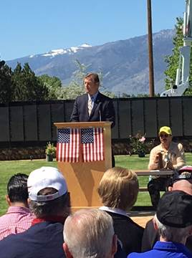

*Heller speaks at the opening ceremony of the Vietnam Moving Wall in Minden, NV.*

A senior member of the U.S. Senate Veterans’ Affairs Committee, Heller continues to introduce and help pass policies that will help Nevada’s 300,000 veterans. In the 115th Congress alone, the President has already signed ten bills that Heller either authored or helped introduce to address the needs of Nevada’s veteran community. That includes legislation to expand veterans’ GI Bill education benefits and ensure veterans continue to have access to life-saving surgeries and treatment.

Last week, the U.S. Senate approved the [VA Mission Act](https://www.heller.senate.gov/public/index.cfm/pressreleases?ID=2127F307-3699-4B5E-92C2-7BD834D037BC), bipartisan legislation that Heller helped introduce to further fund and reform the U.S. Department of Veterans Affairs (VA) Veterans Choice Program, expand eligibility for caregivers, recruit and retain doctors, and streamline the VA health care system. The historic proposal includes three bills authored by Heller to help Nevada’s veteran and military communities, and it has been sent to the President’s desk for his signature.

When discussing the VA Mission Act prior to its passage, **Heller said,** *“*A few weeks ago, a veteran from Gardnerville contacted me and said he prefers to see a doctor at the clinic one mile down the road from his home, but even under the Choice Act – he’s forced to travel 100 miles roundtrip to see a cardiologist and a foot doctor. That doesn’t make any sense, and it is exactly what the VA MISSION Act aims to fix.”

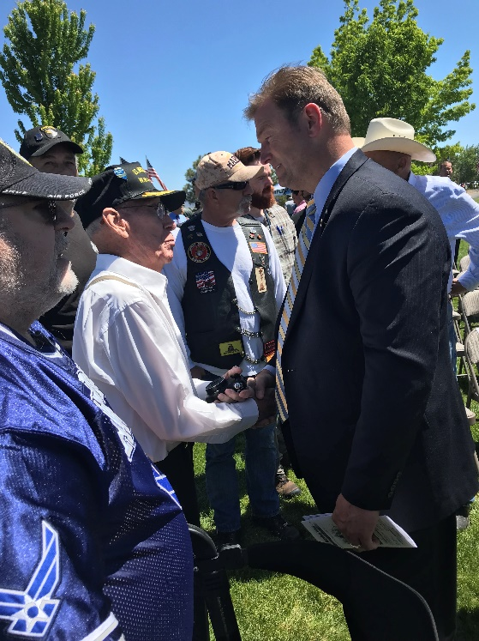                  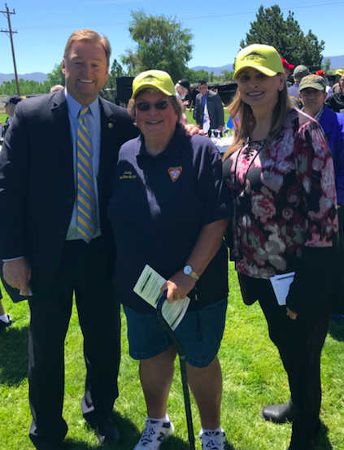     
*Heller greets veterans and volunteers following the ceremony.  
*Media has the permission to use the photographs above.*

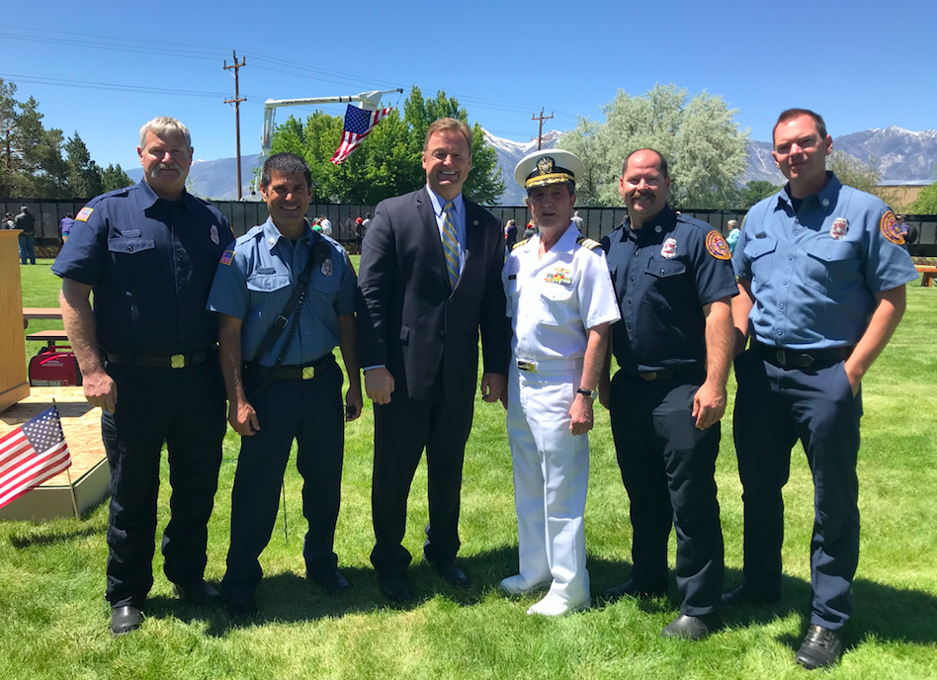

*Heller with Mayor Bob Crowell of Carson City and firefighters from the East Fork Fire Protection District.  
*Media has the permission to use the photographs above.*

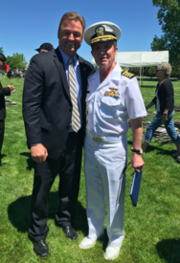  
*Heller with Mayor Bob Crowell.  
*Media has the permission to use the photograph above.*

**Background: Veterans Bills Heller Authored, Helped Introduce, or Co-Led Signed into Law During the 115th Congress:**

* S. 2548 (Heller authored), Veteran Urgent Access to Mental Healthcare Act
* S. 2247 (Heller authored), legislation for VA cemetery improvements
* S.114 (Heller authored), VA Choice and Quality Employment Act
* S. 1362 (Heller authored), Guard and Reservists Education Improvement Act
* S. 1277 (Heller co-led), VET TEC Act
* S. 1024, (Heller original cosponsor) Veterans Appeals Improvement and Modernization Act
* S. 1094, (Heller original cosponsor) Department of Veterans Affairs Accountability and Whistleblower Protection Act
* S. 1598, (Heller original cosponsor) Harry W. Colmery Veterans Educational Assistance Act
* S. 1489, (Heller original cosponsor) Veterans Education Relief and Reinstatement Act
* S.784 (Heller original cosponsor) the Veterans’ Compensation Cost-of-Living Adjustment Act

###

[cid:image002.png@01D454FA.27751A10](http://www.facebook.com/pages/US-Senator-Dean-Heller/325751330177)[cid:image003.png@01D454FA.27751A10](http://twitter.com/SenDeanHeller)[cid:image004.png@01D454FA.27751A10](http://www.youtube.com/user/SenDeanHeller)