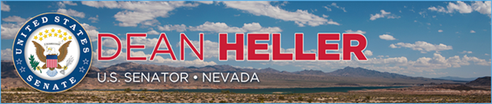

|  |  |
| --- | --- |
| **For Immediate Release:** | **Contact:** [Megan Taylor](mailto:Megan_Taylor@heller.senate.gov) |
| June 27, 2017 | 202-224-6244 |

**Heller Releases Statement on EPA’s Latest WOTUS Announcement**

**Washington, D.C.** – U.S. Senator Dean Heller (R-NV) released the following statement regarding the Environmental Protect Agency’s (EPA) announcement that they have taken additional steps to repeal the Waters of the U.S. (WOTUS) rule, a harmful regulation that would have given the EPA unprecedented control over farms, ranches, and small businesses across Nevada.

“I applaud the EPA for taking additional steps to repeal the Waters of the U.S. (WOTUS) rule, an overreaching and burdensome regulation that would have damaged the economy and stifled job creation in Nevada,” **said Heller**.” Unelected bureaucrats in Washington should never be allowed to wield so much power and influence, and this Obama-era rule was simply Washington run amok. As a sportsmen I grew up understanding the importance of being a good steward to our environment, and going forward we must always work to balance conservation and economic growth.”

In the last Congress, Senator Heller cosponsored the [Federal Water Quality Protection Act](https://www.heller.senate.gov/public/index.cfm/2015/11/heller-wotus-will-devastate-nevada-landowners-and-businesses), legislation that requires the EPA and the USACE to redo WOTUS and consider stakeholder input.

###

[cid:image002.png@01D2EC11.95BD3550](http://www.facebook.com/pages/US-Senator-Dean-Heller/325751330177)[cid:image003.png@01D2EC11.95BD3550](http://twitter.com/SenDeanHeller)[cid:image004.png@01D2EC11.95BD3550](http://www.youtube.com/user/SenDeanHeller)