

|  |  |
| --- | --- |
| **For Immediate Release:** | **Contact:** [Megan Taylor](mailto:Megan_Taylor@heller.senate.gov) |
| September 25, 2017 | 202-224-6244 |

**In Case You Missed It: Heller Says Graham-Cassidy-Heller-Johnson Gives Nevada More Flexibility**

**Washington, D.C.** – During a U.S. Senate Finance Committee hearing this afternoon, U.S. Senator Dean Heller (R-NV) spoke today about the [Graham-Cassidy-Heller-Johnson](https://www.heller.senate.gov/public/index.cfm/pressreleases?ID=AF2F8D9D-9D23-4CA8-9B77-DC5B52D60FBB) health care proposal, legislation that provides states with the money and flexibility needed to determine how to best cover health care costs.

Under this proposal, states would be able to implement tailor-made solutions to their health care challenges. In his opening statement, Heller noted how the bill offers Nevada more flexibility and funding to meet the needs of its population. Click [HERE](https://youtu.be/ziYOfkg0JZ0) to watch the video.

[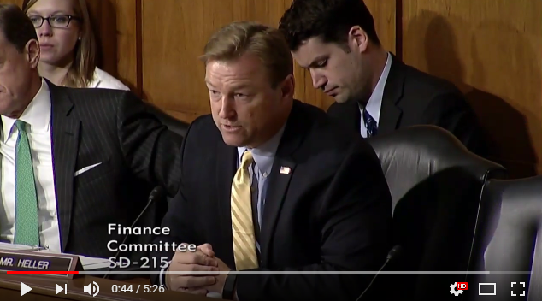](https://youtu.be/ziYOfkg0JZ0)

[Click [here](https://youtu.be/ziYOfkg0JZ0) or the above image to watch]

**Below is his opening statement as prepared for delivery:**

*Chairman Hatch, thank you for holding this hearing today to discuss Graham-Cassidy-Heller-Johnson.*

*I also want to thank my colleagues, Bill Cassidy and Lindsey Graham, for their leadership on this proposal.*

*Over the summer, Bill came to me with an idea that would fundamentally change the way our health care system works.*

*When he told me this plan offered Nevada more flexibility and funding to meet the needs of our patients, I said sign me up.*

*During the past few months, we’ve worked to refine the original amendment that we filed with Senator Graham over the summer, which brings us here today.*

*Our proposal represents what I set out to do from the very beginning of this summer’s health care debate—do what’s best for the citizens of Nevada.*

*We all know that Nevadans and Americans across the country are facing higher costs and fewer choices under Obamacare.*

*I think our colleagues on the other side would agree that the status quo isn’t working for all Americans.*

*As a small government conservative, I believe any solution to our broken health care system needs to be rooted in increased flexibility with the goal of enhancing affordability and access to coverage.*

*A one-sized-fits-all approach isn’t the answer. So, what’s the alternative?*

*Remove Washington from the decision making process.*

*Allow a 50 state solution where each state is empowered to do what they think is best on behalf of their patients.*

*In fact, two weeks ago, I held a telephone tall hall meeting where I heard from a nurse in Las Vegas who is also a patient advocate.*

*She brought up the Graham-Cassidy-Heller-Johnson plan and said she’s glad people in Washington finally get it.*

*She agreed that it’s essential to bring health care decisions down to the state and local levels to improve the quality of care in this country.*

*Our proposal simply takes Obamacare funding and replaces it with a block grant given annually to states to help individuals pay for health care.*

*This plan gives states the flexibility to innovate and create health care systems that will lower premiums, expand coverage, and allow states to serve their Medicaid populations as they see fit.*

*This proposal presents states with many options for coming up with a tailored approach most appropriate for their citizens.*

*For example, states like Nevada that have expanded Medicaid can continue serving this population with their block grant dollars.*

*And, because Nevada won’t be on the hook for the 10 percent match required under Obamacare in 2020, the state will save 1.16 billion dollars.*

*As someone who recognizes the increased needs within our state as a result of the State of Nevada’s decision to expand Medicaid, these provisions are critical.*

*Our proposal also allows states to use up to 20 percent of their block grant on traditional Medicaid, providing states with additional flexibility to serve individuals who rely on this program.*

*Understanding that Nevada is committed to providing affordable, quality care to our patients, including the most vulnerable, our proposal allows them to advance these efforts.*

*For example, Nevada can enter into arrangements with insurers, including managed care providers, to continue its commitment to vulnerable patients, as well as ensure that Nevadans who rely on Medicaid have access to the services they need.*

*Under this proposal, states can also access funds that will allow them to address urgent health care needs at home.*

*These are just a handle of examples of how states can benefit from this proposal through increased flexibility.*

*Senators Cassidy, Graham, and Johnson and I believe our plan is the best path forward to address our nation’s health care challenges.*

*So I’m grateful to the Chairman for allowing us the opportunity today to discuss this proposal.*

*With that, I have a few questions for our witnesses.*

###  
  
[cid:image003.png@01D3362A.A9A6E5D0](http://www.facebook.com/pages/US-Senator-Dean-Heller/325751330177)[cid:image004.png@01D3362A.A9A6E5D0](http://twitter.com/SenDeanHeller)[cid:image005.png@01D3362A.A9A6E5D0](http://www.youtube.com/user/SenDeanHeller)