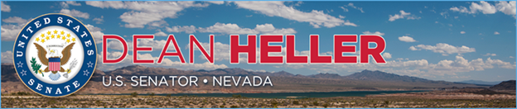

|  |  |
| --- | --- |
| **For Immediate Release:** | **Contact:**[Megan Taylor](mailto:Megan_Taylor@heller.senate.gov) |
| September 11, 2018 | 202-224-6244 |

**Heller Secures Provision to Fund Truckee Meadows Flood Control Project in Comprehensive Water Infrastructure Bill**

**WASHINGTON –** Following the announcement that leaders in the U.S. Senate and U.S. House of Representatives reached a bipartisan, bicameral agreement on comprehensive water infrastructure legislation, U.S. Senator Dean Heller (R-NV) today announced that he successfully secured his provision in the legislation to make sure that the Truckee Meadows Flood Control Project will be awarded the $181 million in federal funding that Congress originally authorized.

[Heller previously worked with the U.S. Senate Environmental and Public Works Committee to ensure that the authorization for Truckee Meadows Flood Control Project would not be in jeopardy as the U.S Army Corps of Engineers evaluates the flood plan](https://www.heller.senate.gov/public/index.cfm/pressreleases?ID=2BC65282-FB32-4DB5-BDE1-87DB117353BD). Heller’s letter to Chairman John Barrasso (R-WY) can be found [HERE](https://www.heller.senate.gov/public/_cache/files/c8f52b76-6d84-4c4c-8c74-fc195ff1c48b/Heller%20Letter%205.18.18.pdf).

“The Truckee Meadows Flood Control Project is a critical local effort that will help mitigate the threats of flash floods throughout Northern Nevada, which have the potential to devastate the infrastructure of our homes, businesses, and roads and bridges,” **said Heller.** “As a Northern Nevadan myself, I realize how important this project is for our community, which is why I worked to secure funding for it in the reconciled water infrastructure legislation. I look forward to continue working with my colleagues to ensure that this legislation is signed into law so that the Truckee Meadows Flood Control Project receives the $181 million in federal funding that it was promised.”

**Background:**

*With Heller’s support, in 2014 the U.S. Senate passed into law the Water Resources Reform and Development Act. Included in the legislation was a provision that authorized $181 million in federal funds for the Truckee Meadows Flood Control Project – an initiative designed to reduce the potential destruction of a 100-year flood. However also comprised in the law was a requirement that if the Truckee Meadows Flood Control Project funds were not disbursed within seven years, the funding would be de-authorized. Knowing the importance of this project to the region, Heller has been working with Senate Environmental and Public Works Committee Chairman Barrasso to fix this de-authorization issue.*

*###*