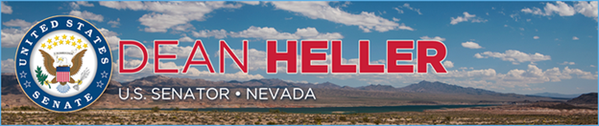

|  |  |
| --- | --- |
| **For Immediate Release:** | **Contact:** [Megan Taylor](mailto:Megan_Taylor@heller.senate.gov) |
| July 24, 2017 | 202-224-6244 |

**Heller Slams House’s Legislative Package for Including Yucca Mountain Funding**

**Washington, D.C.** – The U.S. House of Representatives is voting on a short term spending bill this week and included is $120 million in funding for the Administration’s proposal to re-license Yucca Mountain. The “Minibus” legislation includes the House’s Energy and Water Appropriations bill, which unlike the Senate’s Energy and Water Appropriations bill, provides funding for Yucca Mountain.

“While I am encouraged by actions in the U.S. Senate to fight the re-licensing of Yucca Mountain, the House of Representatives seems determined to ignore the voices of Nevada and waste even more taxpayer dollars on this failed project,” **said Heller**. ”Actions by the House underscore how the fight against Yucca Mountain is far from over, and I will continue to lead the Nevada delegation’s efforts against reviving Yucca Mountain. It’s time for the administration, my colleagues in the House and Senate to abandon this failed project once and for all.”

Last week, [the U.S. Senate Appropriations Committee advanced the Senate’s Energy and Water Appropriations bill excluding funding for Yucca Mountain](https://www.heller.senate.gov/public/index.cfm/pressreleases?ID=691E36A0-8C66-4C9F-B730-01AACAEA879A). Heller previously submitted [testimony](https://www.heller.senate.gov/public/index.cfm/pressreleases?ID=6E1CC11F-3413-4DCE-9E13-632E509919A7) to the Senate Energy & Water Appropriations Subcommittee reiterating his staunch opposition to wasting more taxpayer dollars on the failed project that Nevada continues to reject. testified

*###*

[cid:image002.png@01D3015F.1F24E970](http://www.facebook.com/pages/US-Senator-Dean-Heller/325751330177)[cid:image003.png@01D3015F.1F24E970](http://twitter.com/SenDeanHeller)[cid:image004.png@01D3015F.1F24E970](http://www.youtube.com/user/SenDeanHeller)