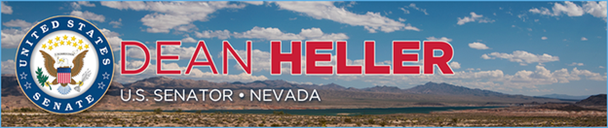

|  |  |
| --- | --- |
| **For Immediate Release:** | **Contact:** [Megan Taylor](mailto:Megan_Taylor@heller.senate.gov) |
| September 18, 2017 | 202-224-6244 |

**Heller Statement on DOI Recommendations Related to Gold Butte**

**Washington, D.C.** – U.S. Senator Dean Heller (R-NV) released the below statement following [reports](https://www.washingtonpost.com/national/health-science/shrink-at-least-4-national-monuments-and-modify-a-half-dozen-others-zinke-tells-trump/2017/09/17/a0df45cc-9b48-11e7-82e4-f1076f6d6152_story.html?utm_term=.b225f03bdfe2) on the Department of Interior (DOI) Secretary Ryan Zinke’s [recommendations](https://www.documentcloud.org/documents/4052225-Interior-Secretary-Ryan-Zinke-s-Report-to-the.html) related to the Gold Butte National Monument:

“As a strong proponent of states’ rights, the Obama Administration’s decision to bypass Congress and designate two national monuments in Nevada despite widespread disagreement at the local level is an example of extreme overreach and the failed Washington-knows-best mentality. That is why I welcomed Secretary Zinke to Nevada to see first-hand the impact of monuments designated under the Antiquities Act with no local input. After talking to and meeting with the Secretary several times, I am pleased that he has taken my recommendation to ask the President to modify Gold Butte’s boundaries to allow the Virgin Valley Water District to access its water rights that were lost under the previous Administration. These actions recommended by me and Secretary Zinke prioritize local concerns over the opinion of Washington bureaucrats, and I hope that President Trump will agree with the Secretary.”

###  
  
[cid:image002.png@01D33065.35378EE0](http://www.facebook.com/pages/US-Senator-Dean-Heller/325751330177)[cid:image003.png@01D33065.35378EE0](http://twitter.com/SenDeanHeller)[cid:image004.png@01D33065.35378EE0](http://www.youtube.com/user/SenDeanHeller)