For Immediate Release: Contact: Chandler Smith
June 10, 2014 202-224-6244

Heller Supports Senate Confirmation of Richard Boulware as U.S. District Court Judge for the District of Nevada
(Washington, D.C.) – Today, the U.S. Senate confirmed Richard F. Boulware II as the U.S. District Court Judge for the District of Nevada. During remarks on the floor of the U.S. Senate yesterday evening, U.S. Senator Dean Heller (R-NV) spoke in support of Mr. Boulware’s confirmation.

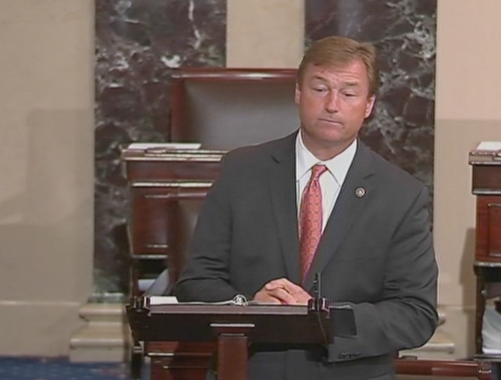

CLICK HERE TO VIEW HELLER’S REMARKS

###

Below are the remarks, as prepared, from Senator Heller’s speech:

Thank you, Mister/Madam President,
Before I begin, I’d like to take a moment to address the unsettling events that occurred yesterday when two members of the Las Vegas Metropolitan Police Department and an innocent civilian were victims of a terrible act of violence. While words offer little comfort at this difficult time, I would like to express my condolences to the victims’ families. The Las Vegas community is grateful to these police officers for their service, and joins their families in mourning their loss. I would also like to thank the men and women of the Las Vegas Metropolitan Police Department who sprung to action following the tragic events, even after losing members of the law enforcement community.

I rise today to speak in favor of a fellow Nevadan’s nomination that is currently pending before this body today, and that is Richard Boulware, nominee for U.S. District Judge for the District of Nevada.

One of the most important and unique responsibilities we hold as members of the United States Senate is to provide for the advice and consent of the President’s judicial nominations and subsequent confirmations.

I believe each judicial nominee which comes before this body must not only be qualified, but also must demonstrate fairness and commitment to upholding the Constitution and the laws of the United States.

In Nevada, it is critical for us to work together to find qualified candidates who will uphold America’s principles of impartiality under law.

Richard Boulware is an excellent example of an accomplished nominee who should be confirmed on a bipartisan basis. I believe Mr. Boulware embodies the characteristics of a nominee who is prepared to serve, and that he will make an excellent District Court judge for the State of Nevada.

After sitting down with him and discussing his nomination at length, I found him to be an extremely impressive nominee. A graduate of Harvard University, Mr. Boulware went on to earn his law degree from Columbia University. He currently serves as Assistant Federal Public Defender for the District of Nevada in Las Vegas.
He also has extensive experience arguing before the Ninth Circuit Court of Appeals. This trial experience, coupled with his impressive academic accomplishments while clerking for the U.S. District Courts, will serve him well on the bench.

Outside of his professional duties, he currently serves his local school system as a member of the Superintendent’s Educational Opportunities Advisory Committee.

I am glad to see the Senate moving forward with this nomination and look forward to voting tomorrow to confirm Mr. Boulware’s nomination to the federal bench in Nevada.

With that Mister/Madam President, I yield the floor.

###

