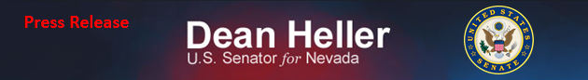
For Immediate Release: Contact: Neal A. Patel
September 4, 2014 202-224-6244

Heller Statement on Tesla Motors

(Washington, DC) - U.S. Senator Dean Heller (R-NV) issued the following statement today after the recent announcement Tesla Motors will be investing up to $5 billion in Nevada for a “gigafactory” projected to employ as many as 6,500 workers by 2020.

“This is wonderful news for Nevada. Our state has struggled to come out of the great recession for some time, but under the leadership of Governor Sandoval, there is light at the end of the tunnel.

“This announcement shows Governor Sandoval’s policy of creating a low-tax environment to attract cutting-edge industry leaders, like Tesla, is working for our state.
“I applaud his leadership and look forward to working with the Governor to create more jobs for families in the Battle Born state.” said Senator Dean Heller.

###

