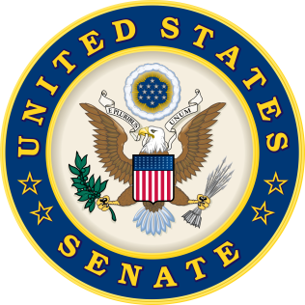
For Immediate Release: | Contacts:
April 27, 2015 | Neal A. Patel/Michawn Rich 202-224-6244 (Heller)
 | Marnee Banks 202-228-0371 (Tester)

Heller and Tester Legislation Encourages Collaboration, Accountability, and Transparency on International Insurance Issues

(Washington, DC) - Today, U.S. Senators Dean Heller (R-NV) and Jon Tester (D-MT), both members of the Senate Banking, Housing, & Urban Affairs Committee, released the following statements after introducing the International Insurance Capital Standards Accountability Act:

“The Federal Reserve and Treasury Department have significantly increased their authority over the U.S. insurance market, and they are now beginning to use their influence more internationally. Our country has a unique 50 state-based insurance regulation system that has served us well and must be preserved. This bi-partisan legislation will establish critical principles and increase Congressional oversight of the Federal Reserve and Treasury Department in order to ensure our best interests are represented at international insurance discussions,” said Senator Heller.

“We need to bring more accountability and transparency to the international insurance process. This bill will add safeguards to better protect consumers and provide Congress with more oversight. Additionally, it will encourage a unified voice from U.S. regulatory agencies at the international level while acknowledging the importance of state-based insurance regulation,” said Senator Tester.

Legislation Summary:
- Establishes an Insurance Policy Advisory Committee on International Capital Standards and other Insurance Issues at the Federal Reserve.

- Requires the Federal Reserve and Treasury Department to annually issue a report and give Congressional testimony on insurance activities at the International Association of Insurance Supervisors and Financial Stability Board.

- Compels the Federal Reserve and Treasury Department, in consultation with the National Association of Insurance Commissioners, to complete a study on the impacts on consumers and markets in the U.S. before supporting any international insurance proposal or international insurance capital standard.

- Supports efforts to increase transparency and public observer access to working groups and meetings at the International Association of Insurance Supervisors.

Attached to this release is a PDF of the International Insurance Capital Standards Accountability Act.

###

