

|  |  |
| --- | --- |
| For Immediate Release: | **Contact:** [Megan Taylor](mailto:Megan_Taylor@heller.senate.gov) |
| November 13, 2017 | 202-224-6244 |

**Heller to Senate Colleagues: It’s Time to Deliver Tax Relief for Hardworking Families**

**Washington, D.C.** – At the U.S. Senate Finance Committee’s markup of the [Tax Cuts and Jobs Act](https://www.heller.senate.gov/public/index.cfm/pressreleases?ID=8A43F3E5-A395-423A-9C46-F201371AC014), Sen. Dean Heller (R-NV) today urged his colleagues to act and deliver on providing tax relief for hardworking families, saying middle-class Nevadans and Americans across the country deserve a shot at a better life. Watch Sen. Heller deliver his opening statement [HERE](https://www.youtube.com/watch?v=_Pp_kNVYats&feature=youtu.be).

[According to the Tax Foundation](https://taxfoundation.org/details-analysis-2017-senate-tax-cuts-and-jobs-act/), the U.S. Senate Finance Committee’s Tax Cuts and Jobs Act will create nearly 1 million new jobs, increase wages by 2.9 percent, grow the economy by 3.7 percent, and provide more than $1.2 trillion of additional revenue for the federal government.

[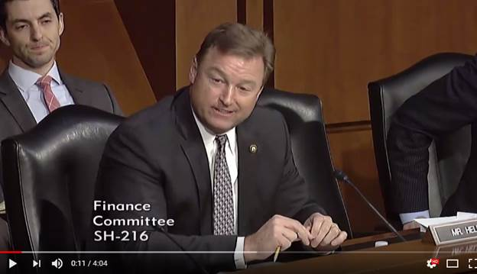](https://www.youtube.com/watch?v=_Pp_kNVYats&feature=youtu.be)

Click [HERE](https://www.youtube.com/watch?v=_Pp_kNVYats&feature=youtu.be) or the image above.

**Sen. Heller’s remarks as prepared for delivery:**

Chairman Hatch, thank you for your leadership and your thoughtful comments.  
  
As many of you know by now, my mom was a school cook and my dad was an auto mechanic.  
  
And they told their children that if you work hard and play by the rules, you’ll succeed and you’ll live the American dream.  
  
However, many Nevadans have told me that this is no longer the case, and that’s the reason why we’re here today.  
  
For too many people, the American dream is slipping away.  
  
Whether it’s the single mother from Las Vegas who doesn’t receive child support, works full time, and is simply trying to make ends meet, or it’s the entrepreneur in Elko who’s fighting hard to get his small business off the ground and wondering whether he’ll ever catch a break and be able to afford to hire his first employee, I continue to hear from decent, hardworking Nevada families and small business owners who are struggling to cover their expenses and get ahead in life.  
  
That’s because for too long, Nevadans and Americans across the country faced stagnant wages and slow economic growth under the failed economic policies of the previous Administration.

As a result of economic policies of the previous Administration, wages and workers suffered.  
  
As a result of economic policies of the previous Administration, job creation suffered.  
  
As a result of economic policies of the previous Administration, middle-class Americans have suffered.  
  
In Nevada, we still bear the scars of failed Obama-era economic policy today.  
  
Real median household income is $7,000 lower today than it was in 2007.  
  
Nevada families are more likely to be living paycheck to paycheck than families living in nearly every other state.  
  
The sad reality is that for most Nevadans, the recession has never really ended.  
  
That’s why I’ve been working each and every day for months with my Republican colleagues on this committee to craft the tax relief package we have in front of us today.  
  
A tax relief bill that accomplishes my three major goals of creating more jobs, increasing wages, and boosting American competitiveness.  
  
A tax bill that provides real, meaningful tax relief to Nevada’s middle class and job creators.  
  
A tax bill that lets the middle class keep more of their hard-earned money and makes our tax code easier to understand.  
  
A tax bill that requires less paperwork and puts more money in people’s back pockets.  
  
A tax bill that results in more jobs, higher wages, and growth in our communities.  
  
A tax bill that significantly increases take-home pay and economic opportunity.  
  
Recent studies by the White House Council of Economic Advisers and a Boston University economist suggest that as a result of this bill, household incomes could rise by an average of $3,500 to $4,000.  
  
Think about what another $3,000 or $4,000 in income will mean to a Nevada family that hasn’t seen a pay raise in ten years.  
  
Middle-class Nevadans and Americans across this great nation deserve a shot at a better life.  
  
We now have a president who is willing to work with us and sign meaningful tax reform into law.  
  
It’s time for this committee to act and deliver on providing true relief to middle-class taxpayers and to reinstate the refrain by my parents that the American dream is not only possible, but will be the reality for those who work hard and play by the rules.  
  
Thank you, Mr. Chairman.

###