

|  |  |
| --- | --- |
| For Immediate Release: | **Contact:** [Megan Taylor](mailto:Megan_Taylor@heller.senate.gov) |
| October 25, 2017 | 202-224-6244 |

**Heller Urges Congress to Deliver a Bigger Child Tax Credit for Nevada’s Hardworking Families**

*Joins Ivanka Trump, Colleagues at Event on Bringing Tax Relief to Americans*

**Washington, D.C.** – U.S. Senator Dean Heller (R-NV), a member of the tax-writing U.S. Senate Finance Committee, today joined Advisor to the President Ivanka Trump and members of the Senate and House at an event in the Capitol highlighting how an enhanced Child Tax Credit will bring tax relief to Nevada’s hardworking families.

Enhancing the Child Tax Credit is a key piece of the Unified Tax Reform Framework that was unveiled last month by the Trump Administration and the leadership of the House Ways and Means and Senate Finance Committees.

Watch Sen. Heller’s remarks [HERE](https://www.youtube.com/watch?v=FLtb0uO5WEs), or click the image below.

[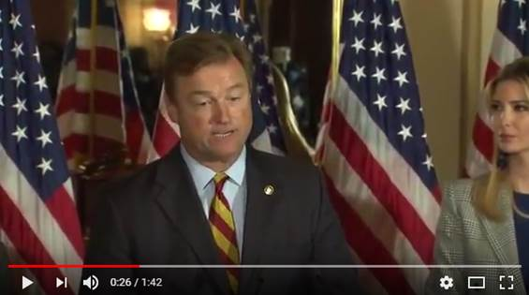](https://www.youtube.com/watch?v=FLtb0uO5WEs)

Click [HERE](https://www.youtube.com/watch?v=FLtb0uO5WEs) or the above image to watch.

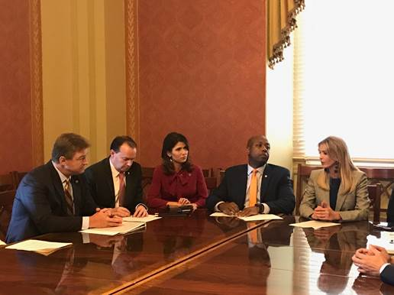

*Heller and Ivanka Trump discuss delivering a child tax credit to American families.*

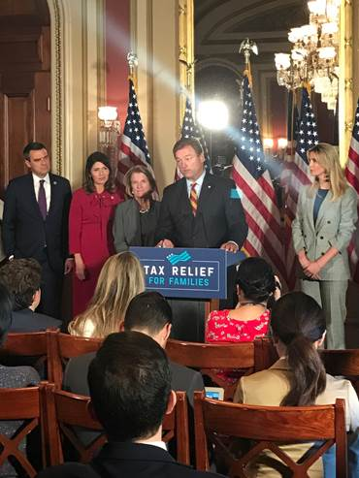

*Heller shares the impact of a child tax credit for Nevada families*

**Sen. Dean Heller’s remarks as prepared for delivery:**   
  
*Hi, I’m Senator Dean Heller from Nevada.*

*I’d like to thank Ivanka for being here with us today to talk about the importance of the child tax credit.*

*Whether it’s the single mother from Gardnerville who doesn’t receive child support and works full-time…or Andrew in Las Vegas who worries about how he’ll be able to afford daycare for his daughters next year, I continue to hear that families in my state are struggling to cover their expenses.*

*That’s in part because for too long – Americans have faced stagnant wages and slow economic growth.*

*In Nevada, median household income is $7,000 lower today than it was in 2007 and families living in my state are more likely to be living paycheck to paycheck than families living in nearly every other state.*

*At the same time, childcare expenses have skyrocketed. In fact, my state is the least affordable in the country when it comes to licensed care for infants.*

*In fact, a single mom living in Clark County would have to spend more than half of her income to send her infant and preschooler to a licensed day care center.*

*This is why an enhanced child tax credit is so important to helping families in Nevada and around this country begin to confront the rising costs of raising their children.*

*What does an enhanced child tax credit mean for the average middle-class Nevada household?*

*It could mean that a teacher’s aide and a police patrol officer with two kids could get a tax refund of more than $250 instead of owing the federal government more than $1,700.*

*Think about this: That’s more than three months-worth of groceries for a family of four. More than 15,000 diapers. It can also get you more than four years’ worth of school supplies for two kids.*

*An enhanced child tax credit could benefit tens of thousands of families in Nevada by saving people in my state – and Americans throughout this country - thousands of dollars.*

*To all of the working families in Nevada and around this country: we’re listening to you. We’re on your side. And I'm joining Ivanka in leading this fight for lower taxes for you. Because I know that when you succeed – your kids will succeed, Nevada will succeed, and our country will succeed.*

###

[cid:image005.png@01D34DAF.1FB22320](http://www.facebook.com/pages/US-Senator-Dean-Heller/325751330177)[cid:image006.png@01D34DAF.1FB22320](http://twitter.com/SenDeanHeller)[cid:image007.png@01D34DAF.1FB22320](http://www.youtube.com/user/SenDeanHeller)