

|  |  |
| --- | --- |
| **For Immediate Release:** | **Contact:** [Megan Taylor](mailto:Megan_Taylor@heller.senate.gov) |
| August 14, 2017 | 202-224-6244 |

**Heller Visits Reno VA Hospital**

*Heller Helped Secure $200 Million in Funding to Expand Hospital*

**Reno, N.V.** – U.S. Senator Dean Heller (R-NV) today toured the Reno Department of Veterans Affairs (VA) Medical Center and met with hospital staff to discuss the unique needs of Nevada’s veterans and the facility’s highly-anticipated construction project.   
  
Heller, a senior member of the Senate Veterans’ Affairs Committee, played a critical role in securing nearly $200 million in federal funds to begin construction on renovations to the Reno VA hospital.

The major construction project, called “Project Nevada’s Heroes,” will involve renovating the medical center’s Building 1 to better handle earthquakes and will also add 155,000 square feet for new outpatient services, including primary care, an eye clinic, and a laboratory. The Veterans Health Administration has given the building an “Exceptionally High Risk” listing because of its potential to collapse in the event of seismic activity.

Lisa Howard, director of VA Sierra Nevada Health Care System, also briefed Heller on mental health services available to veterans and the hospital’s new specialty clinic that offers cardiac treatments, oncology, and other specialty services. The facility also has a new intensive care unit that is currently under construction and expected to be completed soon.

“Nevada’s veterans deserve timely, world-class medical care, and this is something that I continue to fight for every day,” **Heller said.** “By providing cutting-edge and comprehensive services to Nevada’s heroes, the Reno VA Medical Center is restoring our nation’s promise to support the men and women who have selflessly served this country. I’m proud to have worked with leaders at the Reno VA to secure critical federal funds that will help make this facility safer for our veteran patients and the doctors and staff who serve them. I look forward to seeing this project start in the months to come and hope it will make a positive impact for Nevada’s military and veteran communities.”

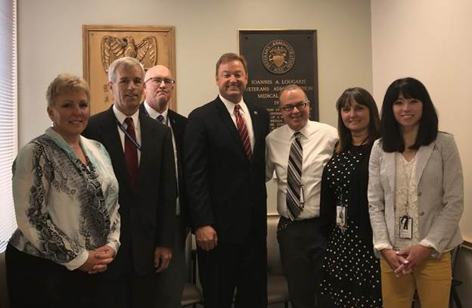

*Senator Heller meets with leaders at the Reno VA Hospital*

The VA is expected to break ground on “Project Nevada’s Heroes” in 2018. It is estimated the project will bring 275-325 new temporary and full-time jobs to the area. The Reno VA hospital is also in design for a parking garage, with expected construction in 2019.

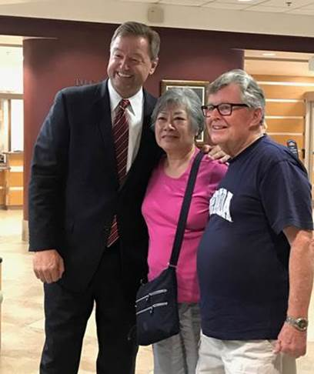

*Senator Heller caught up with patients at the Reno VA*

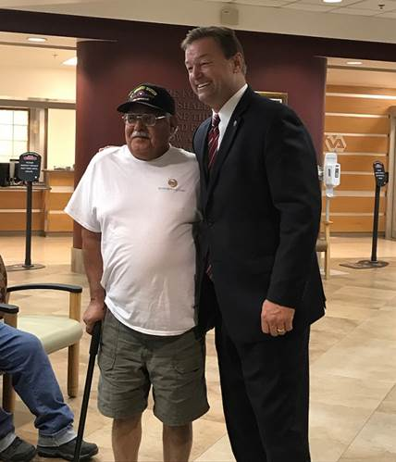

*Senator Heller meets with a veteran at the Reno VA hospital*

The visit comes on the heels of [President Trump signing into law S. 114](https://www.heller.senate.gov/public/index.cfm/pressreleases?ID=C44646E5-2E3D-4F11-AFA2-BAABB30CD49D), legislation introduced by Heller which provides funding for the VA to continue the Veterans Choice Program and improve the quality of care veterans receive in Nevada and around the country.

*###*