For Immediate Release: Contact: Chandler Smith
June 27, 2013 202-224-6244

Heller Votes in Support of Immigration Reform Bill
“The easy thing to do politically is nothing. The harder choice is to govern.”

(Washington, D.C.) – Today, U.S. Senator Dean Heller (R-NV) voted in support of the Border Security, Economic Opportunity, and Immigration Modernization Act (S. 744). Following the vote, Senator Heller issued this statement:

“Today’s final immigration vote represents a product of many long hours of debate, discussion, and deliberation. It takes into consideration the necessity of securing America’s borders, while encouraging the lawful immigration of those who want to come to our shores to contribute to America’s greatness,” said Senator Dean Heller.

“While not perfect, this immigration reform bill is a step in the right direction towards fixing an immigration system that is clearly broken. No question, this has been a contentious debate. While the easy thing to do politically is nothing, the harder choice is to govern. I am pleased that both Democrats and Republicans were able to find ways to work together and pass legislation that this great nation deserves.”

Yesterday, Senator Heller made the following speech on the Senate floor in support of the bill.

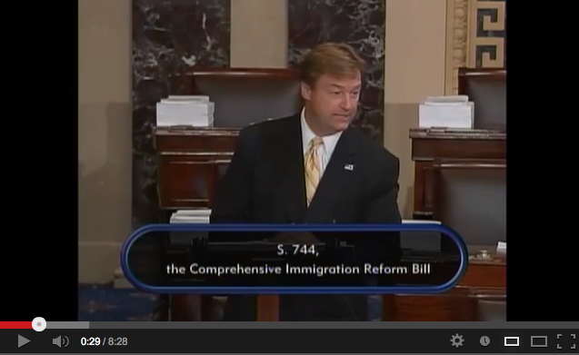

CLICK HERE TO VIEW THE CLIP

Just last week, the U.S. Senate agreed to Senator Heller’s amendment (#1227) to include the southwestern state of Nevada on the Southern Border Security Commission. Heller’s amendment ensures that the Southern Border Security Commission, which is created in the underlying bill, is fully representative of issues affecting southern border and southwestern states.

On Friday, Heller announced his support for an amendment to the immigration bill that will strengthen the existing bill’s border security measures by stiffening the green card trigger. The amendment also included Heller’s proposals to protect Nevada tourism.

###

