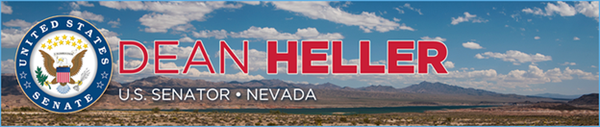

|  |  |
| --- | --- |
| For Immediate Release: | **Contact:** [Megan Taylor](mailto:Megan_Taylor@heller.senate.gov) |
| December 14, 2017 | 202-224-6244 |

**Heller Votes to Confirm Record-Breaking Number of Circuit Court Judges Under President Trump**

**WASHINGTON** – U.S. Senator Dean Heller (R-NV) today voted to confirm James Ho, the 12th circuit court judge nominated by President Trump to be confirmed by the U.S. Senate, marking a new, historic record. The U.S. Senate has now confirmed more circuit court judge nominees under President Trump than any other President has had confirmed during their first year in office.

“I’m proud that the U.S. Senate voted to confirm yet another conservative judge, which brings us to a total of 19 confirmed judges this year, including Justice Neil Gorsuch. Today, we also set a new record; the U.S. Senate has now confirmed more circuit court judge nominees during the first year of President Trump’s Administration than any other president in modern history,” **said Heller.** “Earlier this year, I called on Congress to pick up the pace and now we’ve done exactly that. I’m hopeful that we’ll continue to fill the numerous judicial vacancies and bring tax relief to hardworking Americans. We need to work around the clock until we get the job done.”

In October, [Heller pushed his colleagues to work full-time](https://www.heller.senate.gov/public/index.cfm/pressreleases?ID=A19D527D-5B3F-40E0-8C69-4566450C3C04), 24/7 for the remainder of the year to combat Democrat obstruction and get results for the American people. At the time, the Senate had confirmed only seven judges. Since Heller’s call to speed up the number of confirmations, the Senate has confirmed an additional 12 judges.

According to the Federal Judicial Center, the previous record holders for the most confirmed circuit court judges during their first year in office were Presidents John F. Kennedy and Richard Nixon. The U.S. Senate confirmed 11 federal appeals court nominees during President Kennedy’s and Nixon’s respective first year in office.

###

[cid:image002.png@01D374F5.DAE42270](http://www.facebook.com/pages/US-Senator-Dean-Heller/325751330177)[cid:image003.png@01D374F5.DAE42270](http://twitter.com/SenDeanHeller)[cid:image004.png@01D374F5.DAE42270](http://www.youtube.com/user/SenDeanHeller)