

|  |  |
| --- | --- |
| **For Immediate Release:** | **Contact:**[Megan Taylor](mailto:Megan_Taylor@heller.senate.gov) |
| July 23, 2018 | 202-224-6244 |

**Heller Votes to Confirm Robert Wilkie as Secretary of the Department of Veterans Affairs**

*During Wilkie’s Hearing, Heller Pushed for Benefits for Blue Water Veterans Exposed to Agent Orange, Full-Time Doctor in Pahrump*

**WASHINGTON** – U.S. Senator Dean Heller (R-NV), a senior member of the U.S. Senate Committee on Veterans’ Affairs, today joined a bipartisan vote to confirm the nomination of Robert Wilkie to be the Secretary for the U.S. Department of Veterans Affairs (VA). Heller met with Wilkie earlier this year and also had the opportunity to question Wilkie at a hearing on his nomination last month.

“I was pleased to join my colleagues today to confirm the nomination of Mr. Robert Wilkie as the Secretary of Veterans Affairs on a bipartisan vote,” **said Heller.** “From Nevada’s doctor shortage to taking care of our Blue Water veterans, I had the opportunity to share some of the challenges facing Nevada’s veterans with Mr. Wilkie during our meeting and at his hearing last month. I am encouraged that he outlined potential solutions to some of the issues affecting our veterans, and I welcome his commitment to visit Nevada to hear first-hand from our veteran community. Our nation’s heroes deserve the best quality care and benefits that our country has to offer, and I am confident that Mr. Wilkie shares that belief. I look forward to working with Mr. Wilkie to continue to improve our current system for Nevada’s 300,000 veterans and all of our nation’s heroes.”

During the U.S. Senate Committee on Veterans’ Affairs June hearing on Wilkie’s nomination, Heller [pushed for the VA to provide benefits to Blue Water Navy Vietnam veterans](https://youtu.be/AynSfd_xK2E) who were exposed to Agent Orange while serving during the Vietnam War. Heller also asked for solutions to address the doctor shortages that have particularly affected Nevada’s rural areas such as Elko and Gardnerville, as well as Pahrump, where a new VA clinic still does not have a full-time doctor on staff after opening its doors in 2016. Heller, [who worked for years to secure approval from the VA for construction of the clinic](https://www.heller.senate.gov/public/index.cfm/pressreleases?ID=ED200184-5BB4-4685-9BF7-538C373DDB8C), received a commitment from Wilkie that he will work with Heller to get a full-time doctor in Pahrump by the end of this year.

In addition to doctor shortages, Heller also cited Nevada’s high veteran suicide rate, rural veterans’ access to mental health care services, issues with the VA Caregiver Program in Las Vegas, his work to establish a veterans’ cemetery in Elko, and the VA nursing facility in Reno that is in need of improvements as some of the issues facing Nevada’s 300,000 veterans during Wilkie’s hearing. Wilkie discussed his approach to some of the challenges that Heller highlighted, and he also committed to traveling to Nevada to participate in Heller’s roundtable discussions with veterans. Click [HERE](https://www.youtube.com/watch?v=AynSfd_xK2E&feature=youtu.be) or on the below image to view the exchange between Heller and Wilkie.

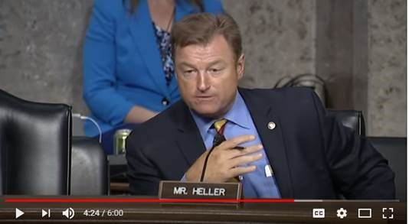

[Click [HERE](https://www.youtube.com/watch?v=AynSfd_xK2E&feature=youtu.be) or on the above image to view the video.]

Given the seriousness of veteran exposure to toxic substances, Heller believes it is important to provide veterans who suffer from the effects of toxic exposure access to the benefits they have earned and deserve. He is a cosponsor of S.422, which would allow Blue Water Navy veterans who served up to 12 miles off-shore in Vietnam presumptive coverage for Agent Orange exposure. Under current law, a Vietnam veteran has to prove a “foot on land” occurrence in order to qualify for the presumptions of service-connection for Agent Orange-related illnesses.

“This is about Agent Orange - I hear from a lot of Nevada veterans on this particular topic, especially from our Blue Water Navy veterans. As you know, the VA doesn’t provide these Blue Water veterans disability benefits they deserve after being exposed and experiencing these harmful effects,” **said Heller during the June hearing.** “I think we can agree that this isn’t right. How do you plan on helping the Blue Water veterans, as well as the veterans exposed to Agent Orange?”

**Wilkie replied,** “I’ll speak to Agent Orange first. I’m from the generation who saw the effects of that on those who’ve come back from Vietnam. So, that is an experience from adolescence that remains with me. On the blue water issue, the House has spoken. And it is my understanding that the issue will be taken up by the Senate, and I stand ready to answer any questions or go down any avenue that this Committee wants in terms of how we address blue water.”

###

[cid:image005.png@01D41926.8854AF90](http://www.facebook.com/pages/US-Senator-Dean-Heller/325751330177)[cid:image006.png@01D41926.8854AF90](http://twitter.com/SenDeanHeller)[cid:image007.png@01D41926.8854AF90](http://www.youtube.com/user/SenDeanHeller)