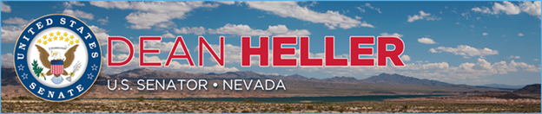

|  |  |
| --- | --- |
| **For Immediate Release:** | **Contact:**[Megan Taylor](mailto:Megan_Taylor@heller.senate.gov) |
| July 12, 2018 | 202-224-6244 |

**Heller Welcomes $1.16 Million Department of Transportation Grant for McCarran International Airport***Heller is a Long-Time Champion of Infrastructure Projects, Boosting Tourism*

**WASHINGTON**– U.S. Senator Dean Heller (R-NV), a member of the U.S. Senate Commerce, Science and Transportation Committee, today announced that McCarran International Airport is expected to receive $1.16 million in grant funding to help extend its taxiway.

Specifically, the U.S. Department of Transportation (DOT) directed $1,162,357.00 to the airport, which is considered one of the busiest airports in the country. According to Clark County Aviation Department, McCarran International Airport had [4.36 million departing and arriving passengers in May 2018](https://www.mccarran.com/pubfile/f285082e-5341-4e6c-99b8-d392b0439f36/1400128/McCarran%20May%202018%20Passengers.pdf?t=20180711-112749), and the Las Vegas Review-Journal [reports](https://www.reviewjournal.com/business/tourism/record-4-3m-passengers-use-mccarran-international-airport-in-may/) that if the airport keeps this pace it could break its previous record of welcoming 48.5 million passengers in 2017.  
  
“As McCarran International Airport continues to welcome millions of passengers each year, it’s critical that the airport has the infrastructure resources it needs to ensure that these outgoing and incoming visitors can travel efficiently, safely, and have a positive experience while doing so,” **said Heller.** “I welcome the Department of Transportation’s $1.16 million federal grant to help our Las Vegas airport extend its taxiway, and thank Secretary Elaine L. Chao again for being a strong supporter of improving Nevada’s infrastructure. As a member of the U.S. Senate Commerce, Science and Transportation Committee, I have the opportunity to stand up for our tourism economy and investing in our airport infrastructure goes hand in hand with drawing more visitors to our state.”  
                                                              
**Background**:  
  
Heller has been a long-time champion of improving Nevada’s aging infrastructure and boosting tourism. Last year, [Heller secured several provisions](https://www.heller.senate.gov/public/index.cfm/2017/6/heller-secures-significant-wins-for-nevada-in-faa-reauthorization-billl) in the FAA Reauthorization Act that will boost Nevada’s travel and tourism economy, help veterans find employment, and promote the state’s drone industry.

*###*