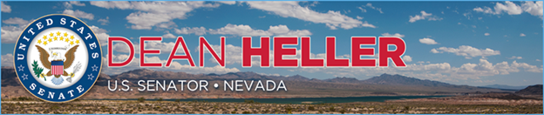

|  |  |
| --- | --- |
| **For Immediate Release:** | **Contact:**[Megan Taylor](mailto:Megan_Taylor@heller.senate.gov) |
| August 7, 2018 | 202-224-6244 |

**Heller Welcomes Grow With Google to Reno For Free Day of Training For Job Seekers, Small Businesses**

**RENO, NV –**U.S. Senator Dean Heller (R-NV) joined Google, local businesses, and job seekers at the Nevada Museum of Art in Reno, Nevada to kick off the [Grow with Google event](https://grow.google/), a free, one-day event designed to help small businesses, students, educators, and entrepreneurs strengthen their digital skills.  
  
“I would like to thank Google for bringing its Grow with Google event to Reno to train job seekers, entrepreneurs, educators, and students who are looking to improve their digital skills. I believe that there’s no better place for it than Nevada – a state that went from having one of the worst unemployment rates during the recession to now being one of the fastest growing states in the nation,” **said Heller during remarks that he delivered at the event.**

*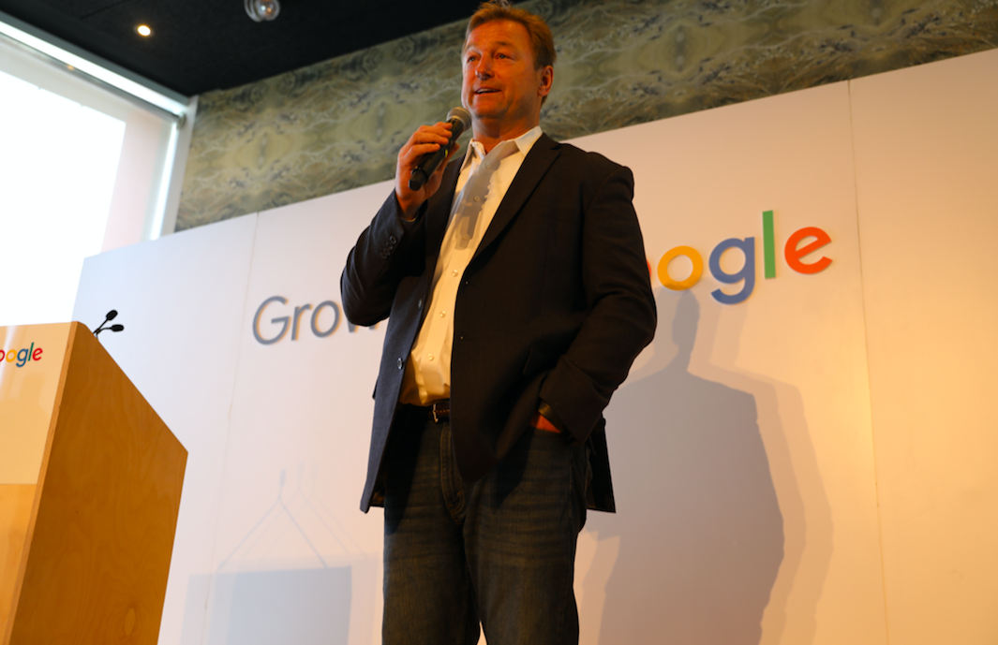  
Heller addresses job seekers, small business owners at Grow with Google event in Reno.*\*Media has permission to use photograph.

From 9:00 a.m. to 5:00 p.m., Nevadans had the opportunity to attend five workshops, one-on-one coaching opportunities, and hands-on demonstrations that focused on topics ranging from online marketing and job search strategies to search engine optimization.

*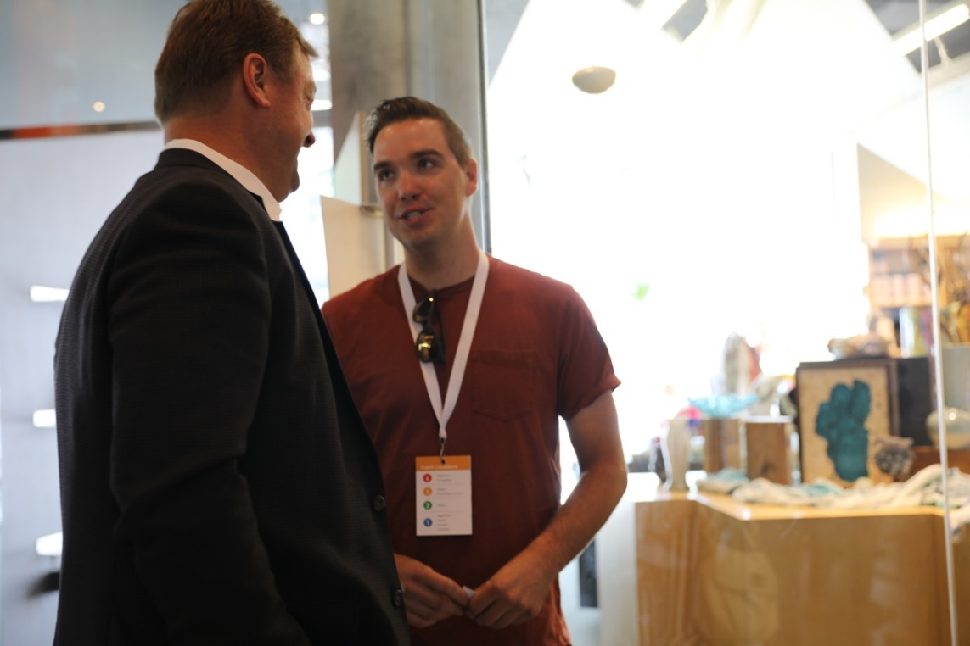  
Heller speaks with Luke Jacobson of Moment Skis.*\*Media has permission to use photograph.

Grow with Google spotlighted Moment Skis, a Reno-based company that manufactures skis, at the event as an example of how Google can be used to increase online sales. According to the owners of Moment Skis, over 75 percent of their business comes from their website. During his remarks, Heller highlighted the company, which has built skis for Olympic athletes including David Wise, Shannon Bahrke, and Heather McPhie, as an example of the success of small businesses in Reno and around the state of Nevada.

“Moment skis is an incredible example of the kind of small businesses that have the opportunity to succeed in our state,” **said Heller.**“Just look around in this community to see the success of local businesses and Reno’s growth. As one of the fastest growing economies per capita, Nevada’s success is not an accident. Our state has created an environment that is friendly to businesses. We have diversified the industries coming into Nevada, and we have provided opportunities for companies to quickly establish facilities and start hiring. The Tahoe-Reno Industrial Center is a great example of that. In fact, our host here today – Google – has a location at TRIC.”

*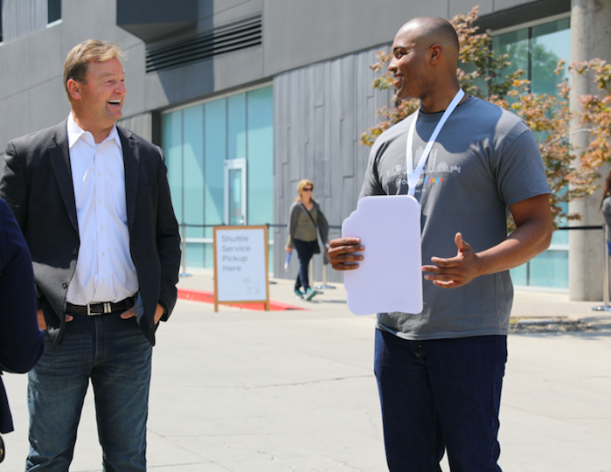  
Heller speaks with members of Google about small business development in Nevada.*\*Media has permission to use photograph.

Heller continued by saying that Nevada continues to lead the nation in economic growth. Last month alone, the state drew in three new companies that are expected to provide good-paying jobs. This includes Bently Heritage in Minden which is expanding its distillery and using locally-grown grains and botanicals, Cyanco in Winnemucca that plans on paying its employees an hourly wage of $44, and Figure Technologies, a blockchain company, that is considering locating itself in downtown Reno and hiring 65 employees for an average of $30 an hour.

[Reno marked the 12thGrow with Google event](https://events.withgoogle.com/join-google-in-reno/) held around the country as part of a larger initiative to increase economic opportunities for Americans throughout the country.

 ###