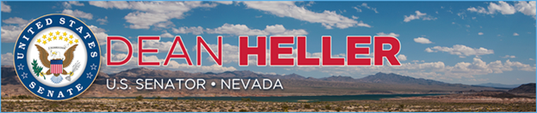

|  |  |
| --- | --- |
| For Immediate Release: | **Contact:** [Megan Taylor](mailto:Megan_Taylor@heller.senate.gov) |
| December 5, 2017 | 202-224-6244 |

**Heller Welcomes Interior Department’s Recommended Action on Gold Butte***Decision Would Allow Local Community to Access Water Rights Lost Under Previous Administration*

**Washington, D.C.** – U.S. Senator Dean Heller (R-NV) today welcomed Department of the Interior (DOI) Secretary Ryan Zinke’s recommendation to the White House to slightly modify the Gold Butte National Monument, which would allow the local community to access water rights that were lost under the Obama Administration.

“The Department of Interior’s decision is welcome news for Nevada as it allows the Valley Water District to access their water rights that were lost under the previous administration,” **said Heller.** “I was proud to work with Secretary Zinke to prioritize local concerns over the opinion of Washington bureaucrats, and I’m pleased with his recommendation to the White House. As this process moves forward, I remain committed to promoting the ‘Nevada’ model of conservation.”

During his last two years in office, President Obama unilaterally placed restrictions on over one million acres of public land in Nevada through the American Antiquities Act of 1906.Given that nearly 85 percent of Nevada is already owned by the federal government, Heller and Rep. Mark Amodei (NV-02) introduced the [Nevada Land Sovereignty Act](https://www.heller.senate.gov/public/index.cfm/2017/1/heller-and-amodei-partner-to-protect-nevada-public-lands-from-executive-overreach),a bill that prevents unilateral land grabs by requiring any monument designation to receive Congressional approval.

“Public lands are for public use, and I believe that communities that border public lands, like those in the Virgin Valley, deserve to have their voices heard in land management decisions. I believe that modest changes to Gold Butte will restore the public voice and will allow for critical public access for water rights and infrastructure. I appreciate the input from local stakeholders and Senator Heller throughout this review process,” **said Secretary Zinke.**

###

[cid:image002.png@01D36DEC.0BFC4D30](http://www.facebook.com/pages/US-Senator-Dean-Heller/325751330177)[cid:image003.png@01D36DEC.0BFC4D30](http://twitter.com/SenDeanHeller)[cid:image004.png@01D36DEC.0BFC4D30](http://www.youtube.com/user/SenDeanHeller)