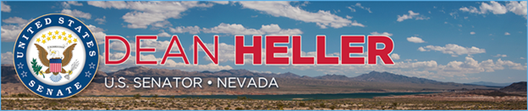

|  |  |
| --- | --- |
| **For Immediate Release:** | **Contact:** [Megan Taylor](mailto:Megan_Taylor@heller.senate.gov) |
| August 30, 2017 | 202-224-6244 |

**Heller Welcomes President’s Commitment to Tax Reform**

*White House’s Outline of Tax Priorities Follows Secretary Mnuchin’s Visit to Las Vegas*

**Washington, D.C.** – U.S. Senator Dean Heller (R-NV) today welcomed President Trump’s commitment to tax reform after he outlined his tax priorities at an event in Springfield, Missouri. A member of the tax-writing U.S. Senate Finance Committee, Heller is a long-time advocate for fixing the country’s broken tax code and lowering rates for individuals and businesses.

On Monday,[Heller welcomed U.S. Treasury Secretary Steven Mnuchin in Las Vegas](https://www.heller.senate.gov/public/index.cfm/pressreleases?ID=D3C0DCA1-F0FC-4984-B631-C559E928F306) for a meeting with Nevada employers in order to learn more about Nevadans’ priorities as Washington gears up for tax reform.   
  
“Congress is ready to address tax reform, and that’s why I’m encouraged by the President’s comments today about bringing tax relief to all Americans. Nevada’s hardworking families and small business owners have been waiting for a simpler, fairer tax code for years now, and Congress and the White House are poised to make that happen,” **Heller said.** “I was honored to host Secretary Mnuchin earlier this week in Las Vegas for a meeting with Nevada employers and the message we received from these business leaders was clear – lowering rates will help boost the economy, create jobs and increase wages. As a member of the Senate Finance Committee, I’m looking forward to working with the Administration on this issue and having a seat at the table to make sure that the final product is what’s best for Nevada.”

*###*[cid:image002.png@01D321A3.572C1910](http://www.facebook.com/pages/US-Senator-Dean-Heller/325751330177)[cid:image003.png@01D321A3.572C1910](http://twitter.com/SenDeanHeller)[cid:image004.png@01D321A3.572C1910](http://www.youtube.com/user/SenDeanHeller)