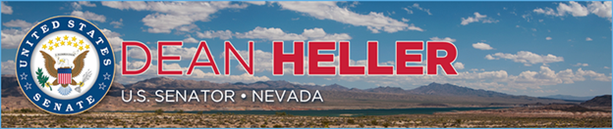

|  |  |
| --- | --- |
| **For Immediate Release:** | **Contact:** [Megan Taylor](mailto:Megan_Taylor@heller.senate.gov) |
| May 18, 2017 | 202-224-6244 |

**ICYMI: Heller: Yucca Mountain Endangers the Entire Country***Proposed Transportation Routes Affect Millions of Americans*

**Washington, D.C.** – U.S. Senator Dean Heller (R-NV) spoke on the U.S. Senate floor today about the dangers of transporting nuclear waste from nuclear power plants around the country to Yucca Mountain and the threat it poses not only to people living in Nevada, but also Americans around the United States. Heller highlighted the proposed transportation routes and the millions of Americans that could be at risk in the event of an accident and radiation exposure. Currently, between 10 and 12 million people live within the radiological region of influence for routine shipments or within one-half mile of these rail and highway routes.

*“And under DOE’s proposal, these shipments would use 22,000 miles of railways and 7,000 miles of highways, crossing over 44 states and the tribal lands of at least 30 Native American Tribes, the District of Columbia, and 960 counties with a 2010 Census population of about 175 million.”*

Heller continues to advocate for a viable solution to our nation’s nuclear waste problem, his bipartisan [Nuclear Waste Informed Consent Act](https://www.heller.senate.gov/public/index.cfm/pressreleases?ID=0a660176-afb7-427d-a988-62918b702c6a). This legislation permits the construction of a nuclear waste repository only if the Secretary of Energy receives written consent from the governor of the host state, affected local officials, and affected Indian tribes. Under Heller’s legislation, state’s like Nevada that do not want to store spent nuclear waste will not be forced to do so by the federal government. Click [HERE](https://www.youtube.com/watch?v=QlxrsaqW92U&feature=youtu.be) or below to watch.

[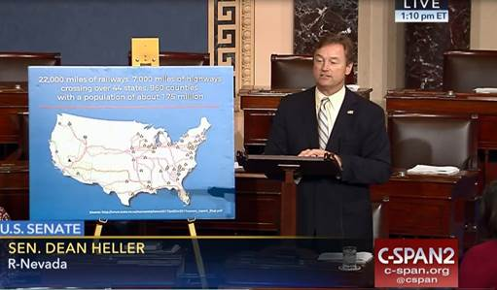](https://www.youtube.com/watch?v=QlxrsaqW92U&feature=youtu.be)

[Click [here](https://www.youtube.com/watch?v=QlxrsaqW92U&feature=youtu.be) or the above image to watch]

**Remarks as prepared for delivery:**

“I rise today to once again speak out against the Administration’s proposal to revive Yucca Mountain. Let me be clear – Yucca is dead. Nevada will not be our nation’s nuclear waste dump.

“I conveyed that message in my meeting with Secretary Perry prior to his confirmation, and again reiterated it ahead of his visit to Yucca in March.

“My former colleague, Senator Harry Reid was a powerful and outspoken opponent of Yucca, and he worked hard to make sure the project didn’t see the light of day.

“Now, I am standing between this Administration and Yucca. And I say to my colleagues on both sides of the aisle that I will lead the fight.

“This is a reckless proposal. Over the past 30 years, the federal government has wasted billions of taxpayer dollars to design and permit Yucca Mountain – all without any signal that Nevada would consent to it.

“A state without a single nuclear power plant should not have to shoulder the entire nation’s nuclear waste burden.

“We will not be run over by the desires of other states that want to move the nuclear waste THEY created out of their backyards and into ours.

‘Let me say it AGAIN – Nevada will not be our nation’s nuclear waste dump!

“Last week’s accident at the Hanford Nuclear Reservation in Washington State serves as a chilling reminder of what Nevada could have to deal with at Yucca Mountain.

“I am relieved that no one was harmed after the tunnel collapsed but believe it serves as a wake-up call to my colleagues. We need to find a viable solution to our nation’s nuclear waste problem.

‘In addition to the potential tragic loss of life, radiation exposure resulting from a similar event at Yucca Mountain could shatter Nevada’s economy.

“This is not to mention the threat of transportation accidents along the proposed waste transportation routes.

“What this means is that under the Nuclear Waste Policy Act, we’re looking at shipping 9,495 rail casks in 2,800 trains, and 2,650 trucks hauling one case each to Yucca Mountain over 50 years.

“If the capacity limit at Yucca is more than doubled as has been discussed, DOE would ship about 21,909 rail casks in about 6,700 trains 5,025 truck casks to Yucca Mountain.

“I ask my colleagues, do you really believe that over the span of 50 years that there won’t be one single transportation accident with an ensuing radiological release?

“And under DOE’s proposal, these shipments would use 22,000 miles of railways and 7,000 miles of highways, crossing over 44 states and the tribal lands of at least 30 Native American Tribes, the District of Columbia, and 960 counties with a 2010 Census population of about 175 million.

“Between 10 and 12 million people live within the radiological region of influence for routine shipments.  That is, within one-half mile of these rail and highway routes.

“In effect, these rail and highway routes would impact most of the nation's congressional districts – estimates show 330 districts.

“And for those of you who are not familiar with the West or Nevada, access to rail corridors or highways is often difficult because they are in remote locations.

“If there was a spill or an accident, questions remain within the Department of Energy regarding their response time for emergency radiological exposure.

“This is not to even mention the issue of private ownership of rail rights-of-way, making it uncertain who would even control accident sites.

“What we do know is that the local communities would be the ones forced to suffer any type of long-term effects of radiation exposure.

“This is in a state that was home to our nation’s nuclear test site and the surrounding communities have suffered for years from resulting exposure.

“I ask my colleagues, should Nevadans be forced once more to shoulder this burden?

“Secretary Perry in response to last week’s accident acknowledged our nation’s problem with nuclear waste, saying that the nation can no longer kick the can down the road.

“Mr. President, I do not believe that our nation should continue to kick the can or the cask in this instance down the road.

“We must find a long-term, viable solution to our nation’s nuclear waste problem, and one that is rooted in consent-based siting.

“I stand ready to work with my colleagues on a solution that ensures that states have a voice in this process.  Failure to do so will only serve to make this problem worse, risking future accidents similar to what we saw last week.

“We can no longer afford to look backwards at failed proposals of the past and waste even more taxpayer dollars.

“Instead we need to move forward on a real solution to a very real problem.”

###

[cid:image002.png@01D2CD66.FDD0BF00](http://www.facebook.com/pages/US-Senator-Dean-Heller/325751330177)[cid:image003.png@01D2CD66.FDD0BF00](http://twitter.com/SenDeanHeller)[cid:image004.png@01D2CD66.FDD0BF00](http://www.youtube.com/user/SenDeanHeller)