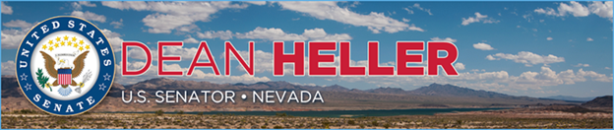

|  |  |
| --- | --- |
| **For Immediate Release:** | **Contact:**[Megan Taylor](mailto:Megan_Taylor@heller.senate.gov) |
| May 11, 2018 | 202-224-6244 |

**Heller, Graham, Lee, and Cruz Heading to Israel for Opening of the U.S. Embassy in Jerusalem**

**WASHIGTON -**U.S. Senator Dean Heller (R-NV) is joining U.S. Senators Lindsey Graham (R-SC), Ted Cruz (R-TX), and Mike Lee (R-UT) in Israel to observe the opening of the United States Embassy in Jerusalem. In addition to the opening ceremony, the senators are scheduled to meet with senior Israeli government officials regarding counter-terrorism and national security issues affecting the United States and Israel.

In 1995, Congress passed legislation that recognized Jerusalem as the capital of Israel by moving the U.S. Embassy from Tel Aviv to Jerusalem. However, although the bill became law later that year, the U.S. Embassy was never moved to Jerusalem. In December of 2017, President Trump formally recognized Jerusalem as the capital of Israel and [announced that the Administration would develop a plan to relocate the U.S. embassy to Jerusalem](https://www.heller.senate.gov/public/index.cfm/pressreleases?ID=89936C1E-D142-4F37-8C9A-9546F84277D8).

“The United States is finally enacting a law that has been on the books for more than two decades by relocating the American embassy to Israel’s true capital, Jerusalem. As the author of legislation that would do just that, I’m pleased that we are fulfilling our promise and righting a wrong,” **said Heller.** “I am looking forward to the ceremony and I am honored to be a part of this momentous occasion.”

Heller has long supported relocating the U.S. embassy from Tel Aviv to Jerusalem. He has repeatedly introduced [the Jerusalem Embassy and Recognition Act](https://www.heller.senate.gov/public/index.cfm/pressreleases?ID=15329846-E3DD-46F0-A16E-784700B8358B), legislation that would fulfill our commitment to moving the embassy by requiring the U.S. Department of State to do so or face a penalty.

###

[cid:image002.png@01D4707F.057F3FD0](http://www.facebook.com/pages/US-Senator-Dean-Heller/325751330177)[cid:image003.png@01D4707F.057F3FD0](http://twitter.com/SenDeanHeller)[cid:image004.png@01D4707F.057F3FD0](http://www.youtube.com/user/SenDeanHeller)