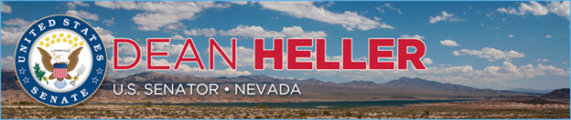

|  |  |
| --- | --- |
| **For Immediate Release:** | **Contact:**[Megan Taylor](mailto:Megan_Taylor@heller.senate.gov) |
| August 6th, 2018 | 202-224-6244 |

**Heller, Nevadans Mourn Passing of Paul Laxalt**

**RENO, NV –**U.S. Senator Dean Heller (R-NV) issued the below statement on the passing of Paul Laxalt, a mentor, friend, and great public servant.

“With a public-service career spanning four decades, Paul epitomized the very best Nevada had to offer by putting service above self. He served as a friend and confidante to numerous Nevadans as his wealth of knowledge steered many of us to seek his valued advice and insight. His down-to-earth, kind demeanor was befitting of his campaign slogan of choice, “One of Us.” Paul was a son of Nevada and indeed one of us. My thoughts and prayers are with the family and friends of Paul as we mourn his passing.”

###