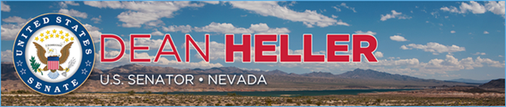

|  |  |
| --- | --- |
| **For Immediate Release:** | **Contact:** [Megan Taylor](mailto:Megan_Taylor@heller.senate.gov) |
| January 11, 2018 | 202-224-6244 |

**Heller, Vice President Pence Speak to Airmen at Nellis Air Force Base**

*Heller, Pence and Secretary Wilson Visit Nellis Air Force Base, AFwerX Vegas*

**Las Vegas, N.V.** – U.S. Senator Dean Heller (R-NV) today introduced Vice President Mike Pence at Nellis Air Force Base in Las Vegas, NV, and also welcomed U.S. Air Force Secretary Heather Wilson to the state. Prior to their visit to Nellis Air Force Base, Heller, Vice President Pence, and Secretary Wilson visited AFwerX Vegas, a new program that brings together the Air Force, entrepreneurs, and more to innovate and improve Air Force capabilities.

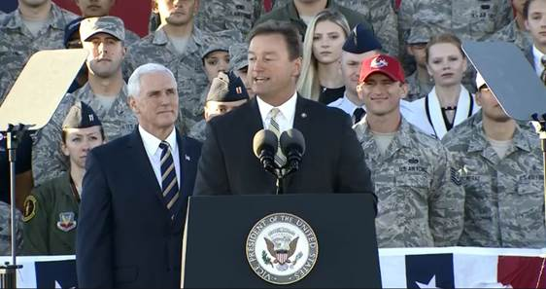  
*Sen. Heller introduces Vice President Pence at Nellis Air Force Base*

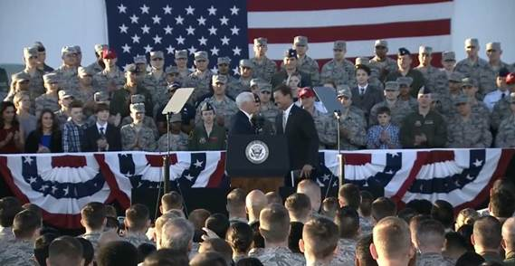

*Vice President Pence takes the podium after Sen. Heller’s introduction*

“The election of President Trump and Vice President Pence gave us the chance to get this country headed in the right direction. And together, we were able to do just that,” **Heller told Airmen and attendees at the base.** “As President Reagan would say, ‘It’s a new day in America.’ Whether it’s fighting to give our troops the largest pay raise in eight years, or working to make it easier for service members to transition back to civilian life, the Vice President and President Trump are your champions.”

Heller supported the National Defense Authorization Act, legislation that provided a 2.4 percent pay increase for our military, the largest pay raise since 2010. Heller is a senior member of the U.S. Senate Veterans’ Affairs Committee and a long-time champion for Nevada’s veteran community. In 2017, the President [signed into law](https://www.heller.senate.gov/public/index.cfm/pressreleases?ID=45CA3448-AC0D-42D6-A7FC-828F5DCBC6E5) eight bills that Heller authored or co-authored specifically aimed at helping Nevada’s 300,000 veterans.

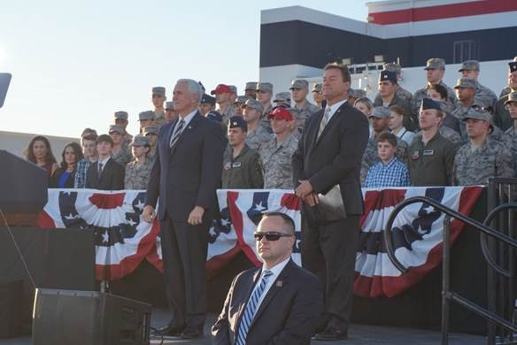

*Vice President Pence and Sen. Heller watch the flyover at Nellis Air Force Base.*

At Nellis Air Force Base, Heller thanked the members of the military who are stationed at Nellis as well as those stationed at Hawthorne, Creech, and Fallon. “I am truly grateful for your service and many contributions to this country. Your leadership, discipline, and commitment to excellence distinguishes you, and that is why I am proud to have five veterans who served combat tours in Afghanistan or Iraq on my staff,” **said Heller.**

Earlier in the afternoon, Heller, Vice President Pence, and Secretary Wilson attended the grand opening of AFwerX Vegas, a new technology accelerator program established by Secretary Wilson in July 2017 to improve the Air Force’s capabilities by connecting innovators and entrepreneurs. AFwerX Vegas is the first site of the AfwerX initiative and located in a 25,000 square foot facility near the University of Nevada, Las Vegas.

At the event, **Vice President Pence** told the crowd that Heller is “a great, great champion of our Armed Forces, a great friend of mine from our days in Congress, and a tenacious advocate for everything about Nevada.”

“It was an honor joining Vice President Pence and Secretary Wilson at the grand opening of AFwerX Las Vegas; I’m so proud that our city is the program’s first site,” **said Heller.** “Thanks to Secretary Wilson’s leadership and work to establish AFwerX Vegas, the Air Force will continue to pursue innovative projects that bring together leaders across all different sectors of our workforce to support the best military in the world.”

“We think the Silver State is the perfect place to open the first AFwerX storefront. Southern Nevada has been on the forefront of innovation and aviation for decades,” **said Vice President Pence.** He went on to say, “Today, the AFwerX Vegas facility will be right at the heart of this city’s thriving technical industry, right around the corner from the world’s most advanced air combat training units, and of course the University of Nevada, Las Vegas with its network of students, faculty, and entrepreneurs.”

**###**

[cid:image008.png@01D38B16.CEF7E410](http://www.facebook.com/pages/US-Senator-Dean-Heller/325751330177)[cid:image009.png@01D38B16.CEF7E410](http://twitter.com/SenDeanHeller)[cid:image010.png@01D38B16.CEF7E410](http://www.youtube.com/user/SenDeanHeller)