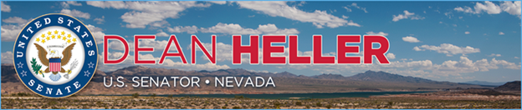

|  |  |
| --- | --- |
| **For Immediate Release:** | **Contact:**[Megan Taylor](mailto:Megan_Taylor@heller.senate.gov) |
| September 7th, 2018 | 202-224-6244 |

**Heller, Vice President Pence Speak to Airmen at Nellis Air Force Base, Visit with Nevada Veterans**

**LAS VEGAS -** U.S. Senator Dean Heller (R-NV) today introduced Vice President Mike Pence and welcomed the U.S. Department of Veterans Affairs (VA) Acting Deputy Secretary James Byrne to Nevada at a rally for airmen at Nellis Air Force Base in Las Vegas, Nevada. In addition to speaking with airmen and their families, Heller, Vice President Pence, and VA Deputy Secretary Byrne visited with Nevada veterans.

“Whether its fully-funding our military, giving our service members the largest pay raise in nearly a decade, or delivering reforms to improve the care our veterans receive at the VA, it is clear that this Administration, President Trump, and Vice President Pence are committed to supporting the men and women who answer our nation’s call,” **Heller stated.**

Vice President Pence, who previously visited Nellis Air Force Base with Heller earlier this year, recognized Heller as a tenacious champion for our Armed Forces, for Nellis Air Force Base, and for the more than 300,000 veterans across Nevada.

“You should all know that Senator Heller stood with us, stood with us every step of the way, as we made these efforts to invest in our national defense. To rebuild our military. Your senator has also stood with us from his position on the Veterans Affairs Committee in the United States Senate to be a champion for our veterans,” **the Vice President said during his remarks**. “President Donald Trump, in our first year and a half, has actually signed more than 15 bills authored and introduced by Senator Dean Heller to improve the services and benefits of veterans all across Nevada and all across the United States,” **he later continued.**

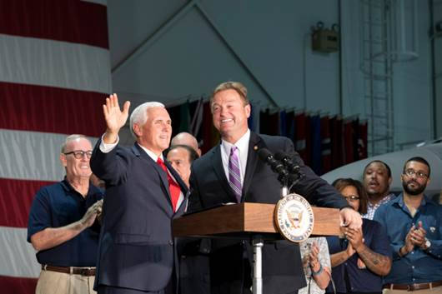

*Vice President Mike Pence delivers remarks Friday, Sept. 7, 2018 at Nellis Air Force Base in Nevada.  (Official White House Photos by Allaina Parton)*

Heller supported the annual defense authorization bill, formally named the John S. McCain National Defense Authorization Act (NDAA), legislation that increases funding for training across all service branches and authorizes a 2.6 percent pay raise for troops – the largest increase in nine years for U.S. service members. President Trump signed the legislation into law on August 13, 2018.

At Nellis Air Force Base, Heller thanked the members of the military who are stationed at Nellis as well as those stationed at Hawthorne, Creech, and Fallon. “I am truly grateful for your service and many contributions to this country. Your leadership, discipline, and commitment to excellence distinguishes you, and that is why I am proud to have several veterans who served combat tours in Afghanistan or Iraq on my staff,” **said Heller.**

As a senior member of the U.S. Senate Committee on Veterans’ Affairs, Heller has been a champion for Nevada’s veteran community. He has authored, helped introduce, and navigate into law more than 40 pieces of legislation designed specifically to help Nevada’s 300,000 veterans, 19 of which were signed into law by President Trump. Just last week, [Heller announced a $1.25 million grant the VA awarded to US Vets in Las Vegas, as well as support to assist veterans organizations around the state to provide additional transitional housing beds for homeless veterans](%3ehttps:/www.heller.senate.gov/public/index.cfm/pressreleases?ID=423698A1-8AF0-4613-83EC-D6D6A7CAAF70%3c).

During his remarks, Heller highlighted the John S. McCain III, Daniel K. Akaka, and Samuel R. Johnson VA Maintaining Internal Systems and Strengthening Integrated Networks (VA MISSION) Act, legislation that he helped send to the President’s desk. [The VA MISSION Act, which included three of Heller’s provisions, directs more than $50 billion to further fund and reform the Veterans Choice Program, expands eligibility for caregivers, helps the VA better recruit and retain doctors, and streamlines the VA health care system](%3ehttps:/www.heller.senate.gov/public/index.cfm/pressreleases?ID=CFEFA8BC-5617-41EA-8B18-DA3A2254F863%3c).

“We have a lot more to do,” **Heller stated.** “I know that this Administration and Congress are just getting started. And you can count on me to use my role on the U.S. Senate Veterans’ Affairs Committee to keep fighting for all of you.”

###

[cid:image003.png@01D446DA.6F4CDC70](%3ehttp:/www.facebook.com/pages/US-Senator-Dean-Heller/325751330177%3c)[cid:image004.png@01D446DA.6F4CDC70](%3ehttp:/twitter.com/SenDeanHeller%3c)[cid:image005.png@01D446DA.6F4CDC70](%3ehttp:/www.youtube.com/user/SenDeanHeller%3c)