

|  |  |
| --- | --- |
| **For Immediate Release:** | **Contact:** [Megan Taylor](mailto:Megan_Taylor@heller.senate.gov) |
| September 13, 2017 | 202-224-6244 |

**VIDEO: Ahead of First Tax Hearing, Heller Shares How Tax Relief Will Impact Nevada Families, Small Businesses**

**Washington, D.C.** – In a [video](https://youtu.be/DcB_qo5ycuU) released today ahead of the U.S. Senate Finance Committee’s first hearing on tax reform tomorrow, U.S. Senator Dean Heller (R-NV) shared how Nevada’s hardworking families and small business will benefit from congressional efforts to fix our country’s outdated, broken, and unfair tax code.

Heller also recently outlined his priorities for tax relief in an [opinion piece published Sunday in the Las Vegas Review-Journal](https://www.heller.senate.gov/public/index.cfm/pressreleases?ID=A55478F6-72E1-4A11-9EB9-DC701FF4BBC6). Click [here](https://youtu.be/DcB_qo5ycuU) or below to watch the video.

[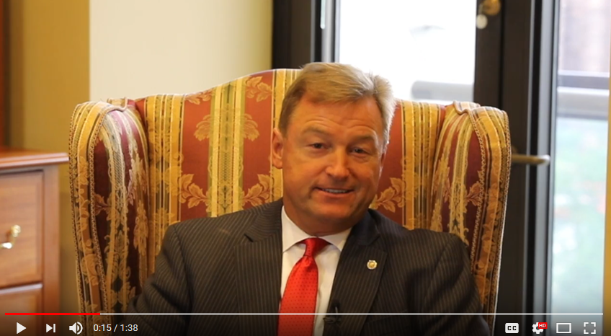](https://youtu.be/DcB_qo5ycuU)

[Click [HERE](https://youtu.be/DcB_qo5ycuU) or the above image to watch]

**The full transcript is available below.**

*Hi, this is Senator Dean Heller and I want to update you on one of my top priorities this fall: bringing tax relief to hardworking Nevadans.*

*For decades, Nevadans have been waiting for an affordable and fair tax code that they can understand. This fall, Congress is ready to take action and we finally have a White House that is on board too.*

*In fact, tomorrow the Senate Finance Committee will hold its first hearing on tax relief.*

*As a member of that committee, I’m working with my colleagues to draft a proposal that accomplishes three major goals:*

*Number 1: creates more jobs*

*Number 2: increases wages*

*And number 3: boosts American competitiveness.*

*Recently, I hosted Treasury Secretary Steve Mnuchin in Nevada where we heard from some of our state’s top employers and the message we received was clear: lowering tax rates for businesses will have an enormous impact on industries all across the spectrum, from tourism to hospitality.*

*So, what does tax reform mean to you?*

*It means that you can keep more of your hard-earned pay check and it will be easier for you to file your taxes. Less paperwork, more money.*

*Lower rates for businesses mean more jobs, higher wages, and growth in our communities – all of which will benefit you.*

*As the son of a school cook and an auto mechanic, I understand the discipline and hard work that goes into every dollar and every paycheck. And I’m working to see that you have more of it in your back pocket.*

*Now that we have a willing partner in the White House, Congress must take action to get this done for Nevadans and Americans everywhere.*

###  
  
[cid:image004.png@01D32CBD.F8684360](http://www.facebook.com/pages/US-Senator-Dean-Heller/325751330177)[cid:image005.png@01D32CBD.F8684360](http://twitter.com/SenDeanHeller)[cid:image006.png@01D32CBD.F8684360](http://www.youtube.com/user/SenDeanHeller)