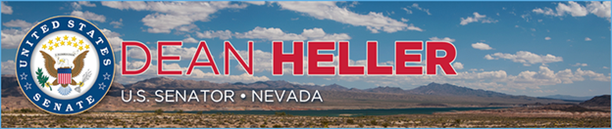

|  |  |
| --- | --- |
| **For Immediate Release:** | **Contact:**[Megan Taylor](mailto:Megan_Taylor@heller.senate.gov) |
| July 28, 2017 | 202-224-6244 |

**House Passes Legislative Package Including Yucca Mountain Funding**

**Washington, D.C.** – U.S. Senator Dean Heller (R-NV) released the below statement following a vote from the U.S. House of Representatives to advance a federal spending package containing the House Energy and Water Appropriations Bill, which includes funding to re-license the Yucca Mountain nuclear repository.

“While I am encouraged by actions in the U.S. Senate to fight the re-licensing of Yucca Mountain, the House of Representatives has charged forward with funding to revive Yucca Mountain,” **said Heller**. “I will continue to lead the Nevada delegation to fight the House's determined efforts to make this failed project a reality and reiterate to my colleagues and the administration that Yucca Mountain is dead."

Recently, [the U.S. Senate Appropriations Committee advanced the Senate’s Energy and Water Appropriations bill, which excluded funding for Yucca Mountain](https://www.heller.senate.gov/public/index.cfm/pressreleases?ID=691E36A0-8C66-4C9F-B730-01AACAEA879A). Heller previously submitted [testimony](https://www.heller.senate.gov/public/index.cfm/pressreleases?ID=6E1CC11F-3413-4DCE-9E13-632E509919A7) to the Senate Energy & Water Appropriations Subcommittee reiterating his staunch opposition to the Yucca Mountain nuclear repository.

*###*[cid:image002.png@01D306F5.237D6150](http://www.facebook.com/pages/US-Senator-Dean-Heller/325751330177)[cid:image003.png@01D306F5.237D6150](http://twitter.com/SenDeanHeller)[cid:image004.png@01D306F5.237D6150](http://www.youtube.com/user/SenDeanHeller)