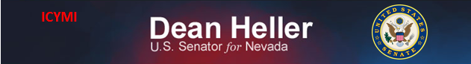

**For Immediate Release:** Contact: Neal A. Patel

February 10, 2015 202-224-6244

**Heller Points to Decline in Banking Options for Nevada**

*Thirty-One Percent of Nevadans are Unbanked or Underbanked*

**(Washington, DC)** – Today, United States Senator Dean Heller asked the following questions at the Senate Committee on Banking, Housing, & Urban Affairs hearing titled, “Regulatory Relief for Community Banks and Credit Unions.” More specifically, Heller voiced his concerns about the decline of financial institutions in Nevada and the extreme costs of opening new banks.

**[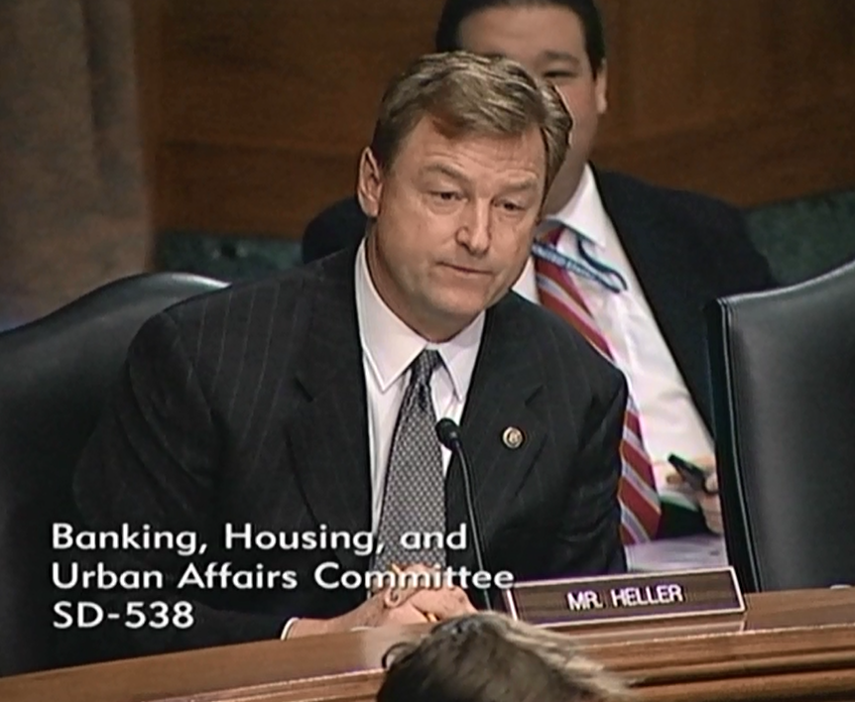](http://youtu.be/9W0Ss5BTXfM?list=UUTS6f940sIirkO6ICyx4ksw)**

[**Click here to watch video.**](http://youtu.be/9W0Ss5BTXfM)

###