

**For Immediate Release:** Contact: Neal A. Patel

September 16, 2014 202-224-6244

**Heller Makes Road Safety in Nevada a Priority by Calling for Flexibility in Safe-Driving Legislation**

**(Washington, DC)** – Today, United States Senator Dean Heller spoke at the Senate Commerce Consumer Protection, Product Safety, and Insurance Subcommittee hearing, “Oversight of and Policy Considerations for the National Highway Traffic Safety Administration,” about the importance of states individually deciding what legislation is necessary to improve safety on the roads. Specifically in Nevada, Heller cited growth within the state on I-11 is a priority in keeping the roads safe with the opening of the Tesla Gigafactory.

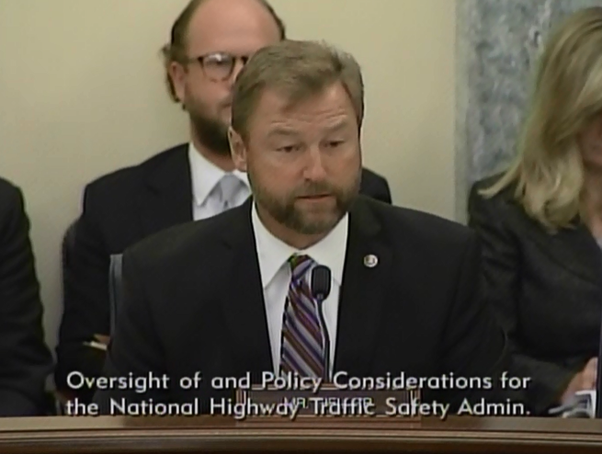

[**Click here to watch video.**](http://youtu.be/4jKvtOoloGw)

REMARKS AS PREPARED:

Good afternoon, thank you Chairman McCaskill for calling this hearing today. I appreciate our witnesses being here and I look forward to this important discussion on NHTSA and its progress in implementing various requirements under MAP-21.

NHTSA plays a vital role in ensuring the highest standards in motor vehicles and highway safety so that we are continually working toward preventing crashes and keeping motorists safe.

I think it goes without saying both the Chairman and I have been very interested in the process at NHTSA, especially in light of the General Motors recall. As it relates to NHTSA, we have paid close attention to what information NHTSA was able to obtain from the car company, what it did with it, and what its role was in the delay to get these cars recalled.

After multiple hearings, I have come to the conclusion that General Motors bears the majority of the blame. NHTSA cannot be effective when auto manufacturers withhold information.

General Motors has admitted that they did not fully understand how their vehicles were built which led to a decade long delay to understand the root cause of the air bag non-deployment was an ignition switch that slipped from run to accessory too easily.

However, NHTSA could have performed better. Energy and Commerce Committee Republicans released a staff report this morning that finds among other things, that NHTSA is struggling to keep pace with the industry it oversees.

This is not a new problem. As some of you may know, in 2009, NHTSA was forced to enlist the help of NASA to supplement its understanding of computer-controlled electronic systems, electromagnetic interference, and software integrity as they relate to unintended acceleration.

I hope we can use today’s hearing to identify areas for improvement at NHTSA, including its internal process for identifying issues and connecting the dots.

I am also concerned the President has not filled the vacancy for the position of Administrator at NHTSA. The task of addressing any shortcomings at the agency and implementing any necessary improvements may be challenging for a deputy Administrator without the endorsement of the President’s nomination and the Senate’s confirmation.

This is all very important for highway safety across America, but NHTSA is also becoming more important for the for the state of Nevada.

Madame Chairman, you may have heard TESLA has selected Nevada for its Gigafactory.

I was proud to help bring TESLA to Nevada. The jobs it will create coupled with the economic boom it will cause in the state are both welcomed benefits of this massive investment.

This factory will bring over 6500 direct, high-paying jobs and billions of dollars in economic impact. This project will increase the employment in the region by more than 20%.

The facility will be one of the largest in the world with five million square feet of the factory devoted to battery manufacturing. This makes Nevada the epicenter of clean vehicle technology.

All of this means Nevada is growing. With that growth, we will need the necessary infrastructure to move people around safely and efficiently.

That is why I am also working on extending Interstate 11 beyond Las Vegas to the northwest part of the state.

And, it is also why I have such an interest in the programs NHTSA administers.

Nevada is going to need flexibility to address the specific state needs and challenges, and I look forward to hearing from our witnesses – in particular, from the Governors State Highway Safety Association – on how best to allocate federal funds to maximize state flexibility without compromising national safety priorities.

Nevada was one of the leading states to develop a Strategic Highway Safety Plan even before it was required by law because Nevada’s highway safety goal is simple: zero fatalities.

Nevada has emphasized five critical areas for reduction of fatal and serious injury crashes that center on:

1. Lane departures – the majority of rural roadway fatalities in Nevada are from lane departures.
2. Pedestrians
3. Impaired Drivers
4. Occupant Protection
5. Intersections

My point in explaining this is that other states may have critical areas and that states may want to allocate funding differently than Nevada.

As we work toward a reauthorization of NHTSA, I want the record to note how different each state is. Therefore, we need a plan flexible enough so each state can come up with a strategy best suited for each individual state to achieve its goal of zero fatalities on the road.

Thank you Chairman McCaskill.

###