

**For Immediate Release:** Contact: Neal A. Patel

March 18, 2015 202-224-6244

**Heller: ObamaCare Offered Everyone Bad Health Care;**

**FCC Takeover Offers Everyone Bad Internet**

[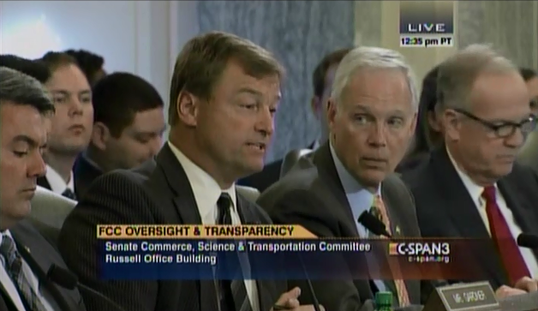](https://youtu.be/NieXvaIbLxI?t=20s)

**[Click here to watch video.](https://youtu.be/NieXvaIbLxI?t=20s)**

###