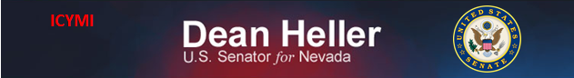

**For Immediate Release:** Contact: Neal A. Patel

December 3, 2014 202-224-6244

**Heller Grills Nominee Rosekind on Future of NHTSA**

**(Washington, DC)** – Today, United States Senator Dean Heller spoke at the Commerce Committee hearing addressing the nomination of Mark Rosekind to be administrator of the National Highway Traffic Safety Administration, along with two other nominations. More specifically, Heller emphasized the importance of Americans knowing they are safe in their vehicles and of employees of NHTSA having proper knowledge of technological features in these cars to ensure safety for consumers.

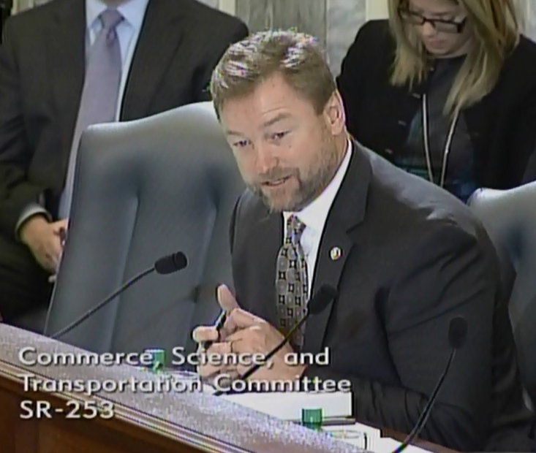

[**Click here to watch video.**](http://youtu.be/XPvPPTR1Z6w)

###