

**For Immediate Release:** Contact: Neal Patel

December 2, 2014 202-224-6244

**Heller Cites Domestic Violence in Professional Sports as Problem**

**(Washington, DC)** – Today, United States Senator Dean Heller spoke at the Commerce Committee hearing, “Addressing Domestic Violence in Professional Sports,” about the necessity to hold professional sports leagues and players accountable for their actions in domestic violence disputes.

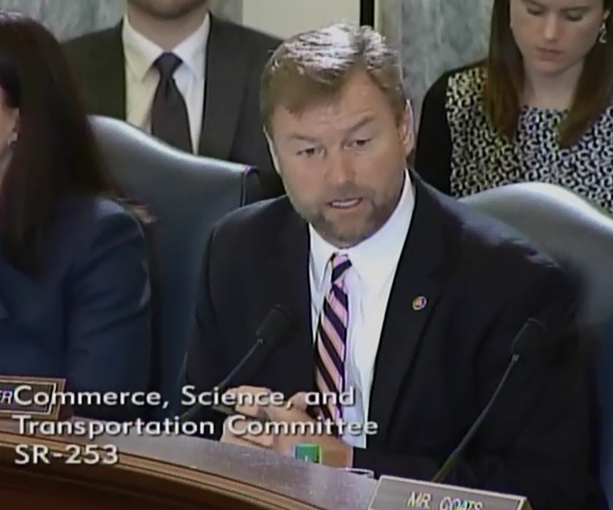

**[Click here to watch video](http://youtu.be/1hHqkjcHyWs).**

REMARKS AS PREPARED:

Thank you Mr. Chairman, and I appreciate the committee’s attention to this important issue.

I know there are some that may question why Congress is involved in this issue. Let me explain why. Every minute in the United States, 20 people will experience domestic violence.

Last night, more than 20,000 phone calls were made to domestic violence hotlines. One in three women will experience physical violence from a partner in their lifetime. And children exposed to domestic violence are more likely commit domestic violence later in life. As a husband, and as a father of two wonderful daughters, this is simply unacceptable and something that must be changed.

These numbers aren’t just statistics – they’re people. They are wives, mothers, daughters, sisters, and friends. The witnesses before us today represent the most popular and commercially successful sports leagues in the world. Their star players are household names and role models for fans and aspiring young athletes.

In the past few years, we’ve witnessed some truly shocking acts from some of these public figures. But just as concerning is how the leagues handled these situations and how the unions protected these players.

It’s very clear to me that getting these players back on the field was more important than addressing incidents of sexual assault, domestic violence, even child abuse. The leagues and the unions simply brushed these problems aside and left it to the courts.

Only when a video surfaced of the brutal punch an NFL player landed on his wife did the collective conscience of America demand these leagues and unions change their approach.

I can only imagine what survivors feel like today.  As I wrote in a letter earlier this year to NFL Commissioner Roger Goodell, by waiting until the video of a shocking act of domestic violence by one of their players became public, they effectively condoned the action of this player.

I believe the same holds true for the players association and in fact don’t think you even understand the full scope of the problem.

When the Ray Rice decision was overturned the NFL Players Association said:

*“This decision is a victory for a disciplinary process that is fair and transparent, this union will always stand up and fight for the due process rights of our players.”*

This is not about due process.  This is not about the collective bargaining agreement you do not like anymore and want to change. This is not about any type of labor issues you may have with the league.

This is about helping to stop a terrible problem in society.  Wives, mothers, sisters, daughters and friends are being beaten.  When you are worrying more about getting back on the field instead of stopping abuse, your priorities are out of order.

Instead of addressing the problem, inadequate or nonexistent league policies and codes of conduct mean that aggressors have not been dealt with appropriately, and the survivors of domestic violence have been left behind.

There is no place in any society for these horrifying acts of domestic violence and sexual assault.

Our nation’s professional sports leagues have a unique ability to make a difference.

The American people need you to step up and this committee wants to know what you’re going to do to take a stand.

###